ME 2202 – Engineering Thermodynamics

ME 2202 Engineering Thermodynamics Mechanical Engineering
2012 - 2013
UNIT – I
Basic Concept and First Law
2 Marks
1. What do you understand by pure substance?
A pure substance is defined as one that is homogeneous and invariable in chemical composition
throughout its mass.
2. Define thermodynamic system.
A thermodynamic system is defined as a quantity of matter or a region in space, on which the analysis
of the problem is concentrated.
3. Name the different types of system.
1. Closed system (only energy transfer and no mass transfer)
2. Open system (Both energy and mass transfer)
3. Isolated system (No mass and energy transfer)
4. Define thermodynamic equilibrium.
If a system is in Mechanical, Thermal and Chemical Equilibrium then the system is in
thermodynamically equilibrium. (or)
If the system is isolated from its surrounding there will be no change in the macroscopic property, then
the system is said to exist in a state of thermodynamic equilibrium.
5. What do you mean by quasi-static process?
Infinite slowness is the characteristic feature of a quasi-static process. A quasi-static process is that a
succession of equilibrium states. A quasi-static process is also called as reversible process.
6. Define Path function.
The work done by a process does not depend upon the end of the process. It depends on the path of the
system follows from state 1 to state 2. Hence work is called a path function.
7. Define point function.
Thermodynamic properties are point functions. The change in a thermodynamic property of a system
is a change of state is independent of the path and depends only on the initial and final states of the
system.
8. Name and explain the two types of properties.
The two types of properties are intensive property and extensive property.
Intensive Property: It is independent of the mass of the system.
Example: pressure, temperature, specific volume, specific energy, density.
Extensive Property: It is dependent on the mass of the system.
Example: Volume, energy. If the mass is increased the values of the extensive properties also
increase.
9. Explain homogeneous and heterogeneous system.
The system consist of single phase is called homogeneous system and the system consist of more than
one phase is called heterogeneous system.
10. What is a steady flow process?
Steady flow means that the rates of flow of mass and energy across the control surface are constant.
11. Prove that for an isolated system, there is no change in internal energy.
In isolated system there is no interaction between the system and the surroundings. There is no mass
transfer and energy transfer. According to first law of thermodynamics as dQ = dU + dW; dU = dQ –
dW; dQ = 0, dW = 0,
There fore dU = 0 by integrating the above equation U = constant, therefore the internal energy is
constant for isolated system.
12. Indicate the practical application of steady flow energy equation.
1. Turbine, 2. Nozzle, 3. Condenser, 4. Compressor.
13. Define system.
It is defined as the quantity of the matter or a region in space upon which we focus attention to study
its property.
14. Define cycle.
It is defined as a series of state changes such that the final state is identical with the initial state.
15. Differentiate closed and open system.
Closed SystemOpen System
1. There is no mass transfer. Only heat and1. Mass transfer will take place, in addition to
work will transfer.the heat and work transfer.
SK Engineering Academy
1

ME 2202 Engineering Thermodynamics Mechanical Engineering
2012 - 2013
2. System boundary is fixed one2. System boundary may or may not change.
3. Ex: Piston & cylinder arrangement, Thermal
3. Air compressor, boiler
power plant
16. Explain Mechanical equilibrium.
If the forces are balanced between the system and surroundings are called Mechanical equilibrium
17. Explain Chemical equilibrium.
If there is no chemical reaction or transfer of matter form one part of the system to another is called
Chemical equilibrium
18. Explain Thermal equilibrium.
If the temperature difference between the system and surroundings is zero then it is in Thermal
equilibrium.
19. Define Zeroth law of Thermodynamics.
When two systems are separately in thermal equilibrium with a third system then they themselves is in
thermal equilibrium with each other.
20. What are the limitations of first law of thermodynamics?
1. According to first law of thermodynamics heat and work are mutually convertible during any cycle
of a closed system. But this law does not specify the possible conditions under which the heat is
converted into work.
2. According to the first law of thermodynamics it is impossible to transfer heat from lower
temperature to higher temperature.
3. It does not give any information regarding change of state or whether the process is possible or not.
4. The law does not specify the direction of heat and work.
21. What is perpetual motion machine of first kind?
It is defined as a machine, which produces work energy without consuming an equivalent of energy
from other source. It is impossible to obtain in actual practice, because no machine can produce energy
of its own without consuming any other form of energy.
22. Define: Specific heat capacity at constant pressure.
It is defined as the amount of heat energy required to raise or lower the temperature of unit mass of the
substance through one degree when the pressure kept constant. It is denoted by Cp.
23. Define: Specific heat capacity at constant volume.
It is defined as the amount of heat energy required to raise or lower the temperature of unit mass of the
substance through one degree when volume kept constant.
24. Differentiate Intensive and Extensive properties
Intensive PropertiesExtensive Properties
1. Independent on the mass of the systemDependent on the mass of the system.
2. If we consider part of the system these If we consider part of the system it will have a
properties remain same.lesser value.
e.g. pressure, Temperature specific volume e.g., Total energy, Total volume, weight etc.,
etc.,
3. Extensive property/mass is known as--
intensive property
25. Define the term enthalpy?
The Combination of internal energy and flow energy is known as enthalpy of the system. It may also
be defined as the total heat of the substance.
Mathematically, enthalpy (H) = U + pv KJ)
Where, U – internal energy
p – pressure
v – volume
In terms of Cp & T → H = mCp (T2-T1)KJ
26. Define the term internal energy
Internal energy of a gas is the energy stored in a gas due to its molecular interactions. It is also defined
as the energy possessed by a gas at a given temperature.
27. What is meant by thermodynamic work?
It is the work done by the system when the energy transferred across the boundary of the system. It is
mainly due to intensive property difference between the system and surroundings.
SK Engineering Academy
2


ME 2202 Engineering Thermodynamics Mechanical Engineering
2012 - 2013
16 Marks
1.
When a system is taken from state l to state m, in Fig., along path lqm, 168 kJ of heat flows into
the system, and the system does 64 kJ of work :
(i) How much will be the heat that flows into the system along path lnm if the work done is 21
kJ?
(ii) When the system is returned from m to l along the curved path, the work done on the system
is 42 kJ. Does the system absorb or liberate heat, and how much of the heat is absorbed or
liberated?
(iii) If Ul = 0 and Un = 84 kJ, find the heat absorbed in the processes ln and nm.
2.
Ql–q–m = 168 kJ
Wl–q–m = 64 kJ
We have, Ql–q–m = (Um – Ul) + Wl–q–m
168 = (Um – Ul) + 64
Um – Ul = 104 kJ. (Ans.)
(i) Ql–n–m = (Um – Ul) + Wl–n–m
= 104 + 21
= 125 kJ. (Ans.)
(ii) Qm–l = (Ul – Um) + Wm–l
= – 104 + (– 42)
= – 146 kJ. (Ans.)
The system liberates 146 kJ.
(iii) Wl–n–m = Wl–n + Wn–m
= Wl–m = 21 kJ[Wn–m = 0, since volume does not change.]
Ql–n = (Un – Ul) + Wl–n
= (84 – 0) + 21
= 105 kJ. (Ans.)
Now Ql–m–n = 125 kJ = Ql–n + Qn–m
Qn–m = 125 – Ql–n
= 125 – 105
= 20 kJ. (Ans.)
A stone of 20 kg mass and a tank containing 200 kg water comprise a system. The stone is 15 m
above the water level initially. The stone and water are at the same temperature initially. If the
stone falls into water, then determine ΔU, ΔPE, ΔKE, Q and W, when
(i) The stone is about to enter the water,
(ii) The stone has come to rest in the tank, and
(iii) The heat is transferred to the surroundings in such an amount that the stone and water come
to their initial temperature.
Mass of stone = 20 kg
Mass of water in the tank = 200 kg
Height of stone above water level = 15 m
Applying the first law of thermodynamics,
(
)
*
+
(
)
Here Q = Heat leaving the boundary.
(i) When the stone is about to enter the water,
SK Engineering Academy
3


ME 2202 Engineering Thermodynamics Mechanical Engineering
Q = 0, W = 0, ΔΥ = 0
– ΔΚΕ = ΔΠΕ
= mg (Z2 – Z1)
= 20 × 9.81 (0 – 15)
= – 2943 J
∴ Δ KE = 2943 J and Δ PE = – 2943 J. (Ans.)
2012 - 2013
(ii) When the stone dips into the tank and comes to rest
Q = 0, W = 0, Δ KE = 0
Substituting these values in eqn. (1), we get
0 = Δ U + 0 + Δ PE + 0
∴ ΔU = – ΔPE = – (– 2943) = 2943 J. (Ans.)
This shows that the internal energy (temperature) of the system increases.
(iii) When the water and stone come to their initial temperature,
W = 0, Δ KE = 0
Substituting these values in eqn. (1), we get
∴ Q = – Δ U = – 2943 J. (Ans.)
The negative sign shows that the heat is lost from the system to the surroundings.
3. A fluid system, contained in a piston and cylinder machine, passes through a complete cycle of
four processes. The sum of all heat transferred during a cycle is – 340 kJ. The system completes
200 cycles per min.
Complete the following table showing the method for each item, and compute the net rate of
work output in kW.
ProcessQ (kJ/min)W (kJ/min)ΔE (kJ/min)
1—204340—
2—3420000—
3—4– 4200—– 73200
4—1———
Sum of all heat transferred during the cycle = – 340 kJ.
Number of cycles completed by the system = 200 cycles/min.
Process 1—2 :
Q=ΔE+W
0 = Δ E + 4340
∴ Δ E = – 4340 kJ/min.
Process 2—3 :
Q=ΔE+W
42000 = Δ E + 0
Δ E = 42000 kJ/min.
Process 3—4 :
Q=ΔE+W
– 4200 = – 73200 + W
∴ W = 69000 kJ/min.
Process 4—1 :
ΣQ cycle = – 340 kJ
The system completes 200 cycles/min
Q1–2 = Q2–3 + Q3–4 + Q4–1
= – 340 × 200
= – 68000 kJ/min
0 + 42000 + (– 4200) + Q4–1 = – 68000
Q4–1 = – 105800 kJ/min.
SK Engineering Academy4

ME 2202 Engineering Thermodynamics Mechanical Engineering
2012 - 2013
4.
Now, ∫ dE = 0, since cyclic integral of any property is zero.
Δ E1–2 + ΔE2–3 + Δ E3–4 + Δ E4–1 = 0
– 4340 + 42000 + (– 73200) + Δ E4–1 = 0
∴ Δ E4–1 = 35540 kJ/min.
∴ W4–1 = Q4–1 – Δ E4–1
= – 105800 – 35540
= – 141340 kJ/min
ProcessQ (kJ/min)W (kJ/min)ΔE (kJ/min)
1—204340– 4340
2—342000042000
3—4– 420069000– 73200
4—1– 105800– 14134035540
Since ΣQ cycle = ΣW cycle
Rate of work output = – 68000 kJ/min
– 68000
60
= 1133.33 kW. (Ans.)
A fluid system undergoes a non-flow frictionless process following the pressure-volume relation
aswhere p is in bar and V is in m3. During the process the volume changes from
0.15 m3 to 0.05 m3 and the system rejects 45 kJ of heat. Determine :
(i) Change in internal energy ;
(ii) Change in enthalpy.
Initial volume, V1 = 0.15 m3
Final volume, V2 = 0.05 m3
Heat rejected by the system, Q = – 45 kJ
Work done is given by,
∫
∫
[
(
∫
)
(
)]
(
)
00
(000 )
0 5
= – 5.64 × 10 N-m = – 5.64 × 105 J
= – 564 kJ
(i) Applying the first law energy equation,
Q=ΔU+W
– 45 = Δ U + (– 564)
∴ ΔU = 519 kJ. (Ans.)
This shows that the internal energy is increased.
(ii) Change in enthalpy,
Δ H = Δ U + Δ (pV)
= 519 × 103 + (p2V2 – p1V1)
[1 Nm = 1 J]
0
= 34.83 × 105 N/m2
00
SK Engineering Academy
5


ME 2202 Engineering Thermodynamics Mechanical Engineering
2012 - 2013
5.
= 101.5 bar = 101.5 × 105 N/m2
∴ Δ H = 519 × 103 + (101.5 × 105 × 0.05 – 34.83 × 105 × 0.15)
= 519 × 103 + 103(507.5 – 522.45)
= 103(519 + 507.5 – 522.45) = 504 kJ
∴ Change in enthalpy = 504 kJ. (Ans.)
The following equation gives the internal energy of a certain substance u = 3.64 pv + 90 where u
is kJ/kg, p is in kPa and v is in m3/kg.
A system composed of 3.5 kg of this substance expands from an initial pressure of 500 kPa and a
volume of 0.25 m3 to a final pressure 100 kPa in a process in which pressure and volume are
related by pv1.25 = constant.
(i) If the expansion is quasi-static, find Q, ΔU and W for the process.
(ii) In another process, the same system expands according to the same pressure-volume
relationship as in part (i), and from the same initial state to the same final state as in part (i), but
the heat transfer in this case is 32 kJ. Find the work transfer for this process.
(iii) Explain the difference in work transfer in parts (i) and (ii).
Internal energy equation : u = 3.64 pv + 90
Initial volume, V1 = 0.25 m3
Initial pressure, p1 = 500 kPa
Final pressure, p2 = 100 kPa
Process: pv1.25 = constant.
(i) Now, u = 3.64 pv + 90
Δ u = u2 – u1 = 3.64 (p2v2 – p1v1) ...per kg
∴ Δ U = 3.64 (p2V2 – p1V1) ...for 3.5 kg
Now, p1V11.25 = p2V21.25
(
)
⁄
00 ⁄
0()
00
= 0.906 m3
ΔU = 3.64 (100 × 103 × 0.906 – 500 × 103 × 0.25) J
= 3.64 × 105 (0.906 – 5 × 0.25) J
= – 3.64 × 105 × 0.344 J = – 125.2 kJ
i.e., ΔU = – 125.2 kJ. (Ans.)
For a quasi-static process
∫
00
0
0
00
0
0 06
[1 Pa = 1 N/m2]
6.
= 137.6 kJ
Q = ΔU + W
= – 125.2 + 137.6
= 12.4 kJ
i.e., Q = 12.4 kJ. (Ans.)
(ii)Here Q = 32 kJ
Since the end states are the same, ΔU would remain the same as in (i)
∴ W = Q – ΔU = 32 – (– 125.2) = 157.2 kJ. (Ans.)
(iii) The work in (ii) is not equal to ∫ p dV since the process is not quasi-static.
0.2 m3 of air at 4 bar and 130°C is contained in a system. A reversible adiabatic expansion takes
place till the pressure falls to 1.02 bar. The gas is then heated at constant pressure till enthalpy
increases by 72.5 kJ. Calculate :
(i) The work done ;
(ii) The index of expansion, if the above processes are replaced by a single reversible polytropic
process giving the same work between the same initial and final states.
Take cp = 1 kJ/kg K, cv = 0.714 kJ/kg K.
SK Engineering Academy
6


ME 2202 Engineering Thermodynamics Mechanical Engineering
2012 - 2013
Initial volume, V1 = 0.2 m3
Initial pressure, p1 = 4 bar = 4 × 105 N/m2
Initial temperature, T1 = 130 + 273 = 403 K
Final pressure after adiabatic expansion,
p2 = 1.02 bar = 1.02 × 105 N/m2
Increase in enthalpy during constant pressure process = 72.5 kJ.
(i) Work done :
Process 1-2 : Reversible adiabatic process :
(
Also
0
(
)
0 (
Mass of the gas,
where, R = (cp – cv) = (1 – 0.714) kJ/kg K
= 0.286 kJ/kg K
= 286 J/kg K or 286 Nm/kg K
0 0
06
860
Process 2-3. Constant pressure :
Q2–3 = m cp (T3 – T2)
72.5 = 0.694 × 1 × (T3 – 272.7)
T3 = 377 K
Also,
V3= 0.732 m3
Work done by the path 1-2-3 is given by
W1–2–3 = W1–2 + W2–3
(
Hence, total work done = 85454 Nm or J.
(ii) Index of expansion, n :
If the work done by the polytropic process is the same,
– –
–
)
(
)
= 0.53 m3
)
= 272.7 K
)
Hence,
n = 1.062
value of index = 1.062. (Ans.)
SK Engineering Academy
7


ME 2202 Engineering Thermodynamics Mechanical Engineering
7.
2012 - 2013
A cylinder contains 0.45 m3 of a gas at 1 × 105 N/m2 and 80°C. The gas is compressed to a
volume of 0.13 m3, the final pressure being 5 × 105 N/m2. Determine :
(i) The mass of gas ;
(ii) The value of index ‘n’ for compression ;
(iii) The increase in internal energy of the gas ;
(iv) The heat received or rejected by the gas during compression.
Take γ = 1.4, R = 294.2 J/kg°C.
Initial volume of gas, V1 = 0.45 m3
Initial pressure of gas, p1 = 1 × 105 N/m2
Initial temperature, T1 = 80 + 273 = 353 K
Final volume after compression, V2 = 0.13 m3
The final pressure, p2 = 5 × 105 N/m2.
(i) To find mass ‘m’ using the relation
0 0
0
(ii) To find index ‘n’ using the relation
( )
00
()
00
n
(3.46) = 5
Taking log on both sides, we get
n loge 3.46 = loge 5
n = loge 5/loge 3.46 = 1.296. (Ans.)
(iii) In a polytropic process,
0
( )()
0
∴ T2 = 353 × 1.444 = 509.7 K
Now, increase in internal energy,
Δ U = mcv (T2 – T1)
(
(iv) Q = Δ U + W
0
–
)
= 49.9 kJ. (Ans.)
(
)
8.
(0 )
6
= – 67438 N-m or – 67438 J = – 67.44 kJ
∴ Q = 49.9 + (– 67.44) = – 17.54 kJ
3
0.1 m of an ideal gas at 300 K and 1 bar is compressed adiabatically to 8 bar. It is then cooled at
constant volume and further expanded isothermally so as to reach the condition from where it
started. Calculate :
(i) Pressure at the end of constant volume cooling.
(ii) Change in internal energy during constant volume process.
(iii) Net work done and heat transferred during the cycle. Assume
cp = 14.3 kJ/kg K and cv = 10.2 kJ/kg K.
Given: V1 = 0.1 m3 ; T1 = 300 K ; p1 = 1 bar ; cp = 14.3 kJ/kg K ; cv = 10.2 kJ/kg K.
(i) Pressure at the end of constant volume cooling, p3:
0
0
Characteristic gas constant,
R = cp – cv = 14.3 – 10.2 = 4.1 kJ/kg K
Considering process 1-2, we have :
SK Engineering Academy
8

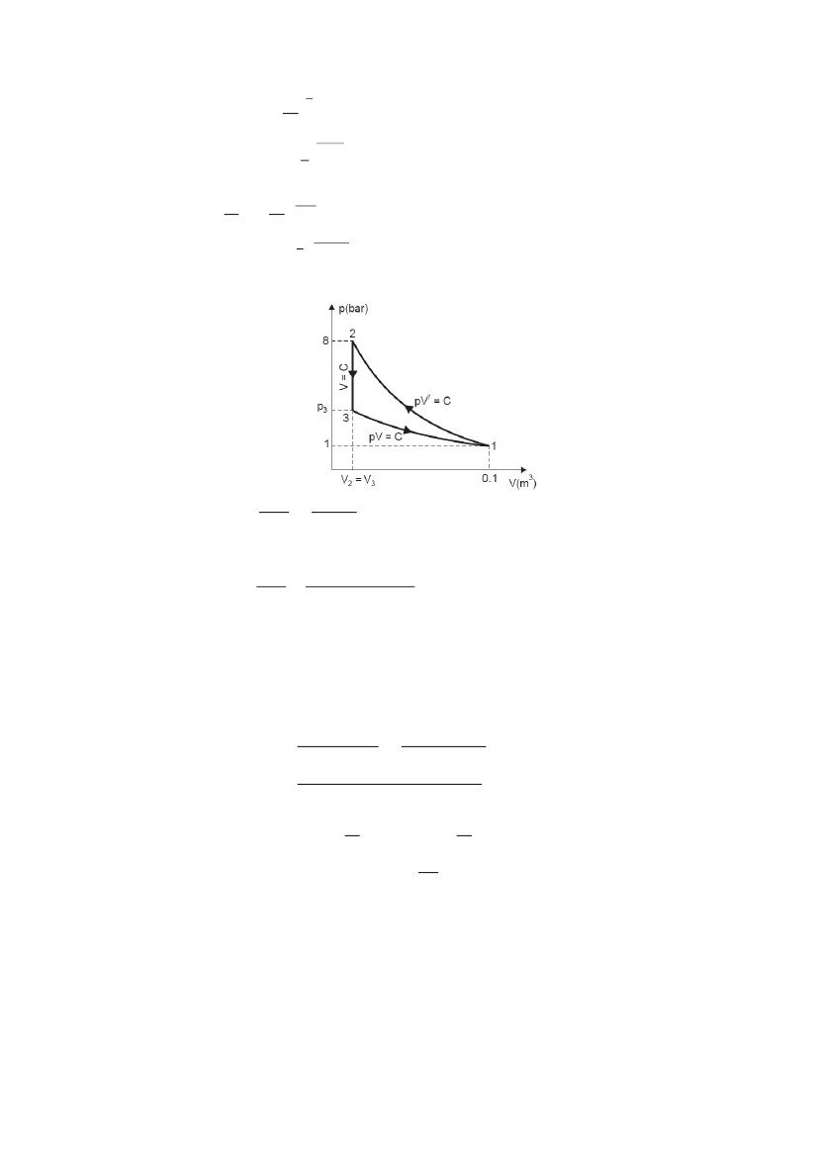
ME 2202 Engineering Thermodynamics Mechanical Engineering
(
0
00
(
)
= 544.5 K
)
( )
8
2012 - 2013
00 ( )
Considering process 3–1, we have
p3V3 = p1V1
0
00
(ii) Change in internal energy during constant volume process, (U3 – U2) :
Mass of gas,
0 0
0 008
00000
Change in internal energy during constant volume process 2–3,
U3 – U2 = mcv(T3 – T2)
= 0.00813 × 10.2 (300 – 544.5)(Since T3 = T1)
= – 20.27 kJ (Ans.) (– ve sign means decrease in internal energy)
● During constant volume cooling process, temperature and hence internal energy is reduced.
This decrease in internal energy equals to heat flow to surroundings since work done is zero.
(iii) Net work done and heat transferred during the cycle :
()
0 008
( 00
)
– 0
0
W2–3 = 0 ... since volume remains constant
( )
(
0 ) 0
(
)
(
)
= 14816 Nm (or J) or 14.82 kJ
∴ Net work done = W1–2 + W2–3 + W3–1
= (– 20.27) + 0 + 14.82
= – 5.45 kJ
–ve sign indicates that work has been done on the system. (Ans.)
For a cyclic process :
∮
∮
∴ Heat transferred during the complete cycle = – 5.45 kJ
–ve sign means heat has been rejected i.e., lost from the system. (Ans.)
SK Engineering Academy
9

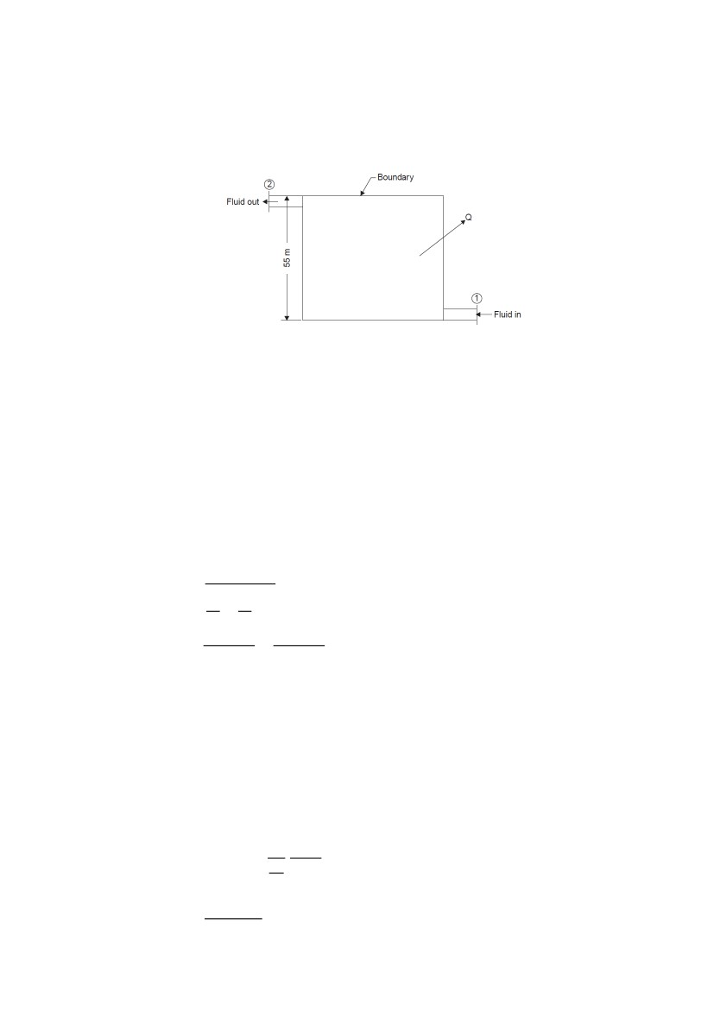
ME 2202 Engineering Thermodynamics Mechanical Engineering
9.
2012 - 2013
10 kg of fluid per minute goes through a reversible steady flow process. The properties of fluid at
the inlet are: p1 = 1.5 bar, ρ1 = 26 kg/m3, C1 = 110 m/s and u1 = 910 kJ/kg and at the exit are p2 =
5.5 bar, ρ2 = 5.5 kg/m3, C2 = 190 m/s and u2 = 710 kJ/kg. During the passage, the fluid rejects 55
kJ/s and rises through 55 metres. Determine :
(i) The change in specific enthalpy (Δ h) ;
(ii) Work done during the process (W).
Flow of fluid = 10 kg/min
Properties of fluid at the inlet :
Pressure, p1 = 1.5 bar = 1.5 × 105 N/m2
Density, ρ1 = 26 kg/m3
Velocity, C1 = 110 m/s
Internal energy, u1 = 910 kJ/kg
Properties of the fluid at the exit :
Pressure, p2 = 5.5 bar = 5.5 × 105 N/m2
Density, ρ2 = 5.5 kg/m3
Velocity, C2 = 190 m/s
Internal energy, u2 = 710 kJ/kg
Heat rejected by the fluid,
Q = 55 kJ/s
Rise is elevation of fluid = 55 m.
(i) The change in enthalpy,
Δh = Δu + Δ(pv)
(
)
0
5
0
65
= 1 × 10 – 0.0577 × 10
= 105 × 0.9423 Nm or J
= 94.23 kJ
Δu = u2 – u1
= (710 – 910)
= – 200 kJ/kg
Substituting the value in eqn. (i), we get
Δh = – 200 + 94.23
= – 105.77 kJ/kg. (Ans.)
(ii) The steady flow equation for unit mass flow can be written as
Q = Δ KE + Δ PE + Δ h + W
where Q is the heat transfer per kg of fluid
0
60
= 55 × 6 = 330 kJ/kg
SK Engineering Academy
10


ME 2202 Engineering Thermodynamics Mechanical Engineering
0
0
2012 - 2013
= 12000 J or 12 kJ/kg
ΔPE = (Z2 – Z1) g = (55 – 0) × 9.81 Nm or J
= 539.5 J or ≈ 0.54 kJ/kg
Substituting the value in steady flow equation,
– 330 = 12 + 0.54 – 105.77 + W or W
= – 236.77 kJ/kg.
– 6= – 39.46 kJ/s
= – 39.46 kW. (Ans.)
10. At the inlet to a certain nozzle the enthalpy of fluid passing is 2800 kJ/kg, and the velocity is 50
m/s. At the discharge end the enthalpy is 2600 kJ/kg. The nozzle is horizontal and there is
negligible heat loss from it.
(i) Find the velocity at exit of the nozzle.
(ii) If the inlet area is 900 cm2 and the specific volume at inlet is 0.187 m3/kg, find the mass flow
rate.
(iii) If the specific volume at the nozzle exit is 0.498 m3/kg, find the exit area of nozzle.
Conditions of fluid at inlet (1) :
Enthalpy, h1 = 2800 kJ/kg
Velocity, C1 = 50 m/s
Area, A1 = 900 cm2 = 900 × 10–4 m2
Specific volume, v1 = 0.187 m3/kg
Conditions of fluid at exit (2) :
Enthalpy, h2 = 2600 kJ/kg
Specific volume, v2 = 0.498 m3/kJ
Area, A2 =?
Mass flow rate, ̇ =?
(i) Velocity at exit of the nozzle, C2 :
Applying energy equation at ‘1’ and ‘2’, we get
were Q = 0, W = 0, Z1 = Z2
( 800 – 600)
= 201250 N-m
∴ C2 = 402500
∴ C2 = 634.4 m/s. (Ans.)
2
000
0
(ii) Mass flow rate ̇ :
By continuity equation,
̇
00
0 8
∴ Mass flow rate = 24.06 kg/s. (Ans.)
00
0
SK Engineering Academy
11


ME 2202 Engineering Thermodynamics Mechanical Engineering
iii) Area at the exit, A2 :
̇
6
2012 - 2013
0 8
A2 = 0.018887 m2 = 188.87 cm2
Hence, area at the exit = 188.87 cm2. (Ans.)
11. Air at a temperature of 20°C passes through a heat exchanger at a velocity of 40 m/s where its
temperature is raised to 820°C. It then enters a turbine with same velocity of 40 m/s and expands
till the temperature falls to 620°C. On leaving the turbine, the air is taken at a velocity of 55 m/s
to a nozzle where it expands until the temperature has fallen to 510°C. If the air flow rate is 2.5
kg/s, calculate :
(i) Rate of heat transfer to the air in the heat exchanger ;
(ii) The power output from the turbine assuming no heat loss ;
(iii) The velocity at exit from the nozzle, assuming no heat loss.
Take the enthalpy of air as h = cpt, where cp is the specific heat equal to 1.005 kJ/kg°C and t the
temperature.
06
Temperature of air, t1 = 20°C
Velocity of air, C1 = 40 m/s.
Temperature of air after passing the heat exchanger, t2 = 820°C
Velocity of air at entry to the turbine, C2 = 40 m/s
Temperature of air after leaving the turbine, t3 = 620°C
Velocity of air at entry to nozzle, C3 = 55 m/s
Temperature of air after expansion through the nozzle, t4 = 510°C
Air flow rate, ̇ = 2.5 kg/s.
(i) Heat exchanger :
Rate of heat transfer :
Energy equation is given as,
Here, Z1 = Z2, C1, C2 = 0, W1–2 = 0
∴ mh1 + Q1–2 = mh2
or Q1–2 = m(h2 – h1)
= mcp (t2 – t1)
= 2.5 × 1.005 (820 – 20)
= 2010 kJ/s.
Hence, rate of heat transfer = 2010 kJ/s. (Ans.)
(ii) Turbine :
Power output of turbine :
Energy equation for turbine gives
(
)
(
(
*(
SK Engineering Academy
)
12
)
)
(
(
)+

[Since Q2–3 = 0, Z1 = Z2]
)

ME 2202 Engineering Thermodynamics Mechanical Engineering
* (
)
(
6 0)
(
)+
0
)+
2012 - 2013
* 00 (8 0
= 2.5 [201 + 0.7125] = 504.3 kJ/s or 504.3 kW
Hence, power output of turbine = 504.3 kW. (Ans.)
(iii) Nozzle:
Velocity at exit from the nozzle :
Energy equation for nozzle gives,
[Since W3–4 = 0, Q3 – 4 = 0, Z1 = Z2]
(
(
)
)
0)
000
00 (6 0
C4 = 473.4 m/s.
Hence, velocity at exit from the nozzle = 473.4 m/s. (Ans.)
UNIT II
Second Law
2 Marks
1. Define Clausius statement.
It is impossible for a self-acting machine working in a cyclic process, to transfer heat from a body at
lower temperature to a body at a higher temperature without the aid of an external agency.
2. What is Perpetual motion machine of the second kind?
A heat engine, which converts whole of the heat energy into mechanical work is known as Perpetual
motion machine of the second kind.
3. Define Kelvin Planck Statement.
It is impossible to construct a heat engine to produce network in a complete cycle if it exchanges heat
from a single reservoir at single fixed temperature.
4. Define Heat pump.
A heat pump is a device, which is working in a cycle and transfers heat from lower temperature to
higher temperature.
5. Define Heat engine.
Heat engine is a machine, which is used to convert the heat energy into mechanical work in a cyclic
process.
6. What are the assumptions made on heat engine?
1. The source and sink are maintained at constant temperature.
2. The source and sink has infinite heat capacity.
7. State Carnot theorem.
It states that no heat engine operating in a cycle between two constant temperature heat reservoir can
be more efficient than a reversible engine operating between the same reservoir.
8. What is meant by reversible process?
A reversible process is one, which is performed in such a way that at the conclusion of process, both
system and surroundings may be restored to their initial state, without producing any changes in rest of
the universe.
9. What is meant by irreversible process?
The mixing of two substances and combustion also leads to irreversibility. All spontaneous process is
irreversible.
10. Explain entropy?
It is an important thermodynamic property of the substance. It is the measure of molecular disorder. It
is denoted by S. The measurement of change in entropy for reversible process is obtained by the
quantity of heat received or rejected to absolute temperature.
SK Engineering Academy
13

ME 2202 Engineering Thermodynamics Mechanical Engineering
2012 - 2013
11. What is absolute entropy?
The entropy measured for all perfect crystalline solids at absolute zero temperature is known as
absolute entropy.
12. Define availability.
The maximum useful work obtained during a process in which the final condition of the system is the
same as that of the surrounding is called availability of the system.
13. Define available energy and unavailable energy.
Available energy is the maximum thermal useful work under ideal condition. The remaining part,
which cannot be converted into work, is known as unavailable energy.
14. Explain the term source and sink.
Source is a thermal reservoir, which supplies heat to the system and sink is a thermal reservoir, which
takes the heat from the system.
15. What do you understand by the entropy principle?
The entropy of an isolated system can never decrease. It always increases and remains constant only
when the process is reversible. This is known as principle of increase in entropy or entropy principle.
16. What are the important characteristics of entropy?
1. If the heat is supplied to the system then the entropy will increase.
2. If the heat is rejected to the system then the entropy will decrease.
3. The entropy is constant for all adiabatic frictionless process.
4. The entropy increases if temperature of heat is lowered without work being done as in throttling
process.
5. If the entropy is maximum, then there is a minimum availability for conversion in to work.
6. If the entropy is minimum then there is a maximum availability for conversion into work.
17. What is reversed carnot heat engine? What are the limitations of carnot cycle?
1. No friction is considered for moving parts of the engine.
2. There should not be any heat loss.
18. Define an isentropic process.
Isentropic process is also called as reversible adiabatic process. It is a process which follows the law
of pVy = C is known as isentropic process. During this process entropy remains constant and no heat
enters or leaves the gas.
19. Explain the throttling process.
When a gas or vapour expands and flows through an aperture of small size, the process is called as
throttling process.
20. What are the Corollaries of Carnot theorem.
(i) In the entire reversible engine operating between the two given thermal reservoirs with fixed
temperature, have the same efficiency.
(ii) The efficiency of any reversible heat engine operating between two reservoirs is independent of the
nature of the working fluid and depends only on the temperature of the reservoirs.
21. Define – PMM of second kind.
Perpetual motion machine of second kind draws heat continuously from single reservoir and converts
it into equivalent amount of work. Thus it gives 100% efficiency.
22. What is the difference between a heat pump and a refrigerator?
Heat pump is a device which operating in cyclic process, maintains the temperature of a hot body at a
temperature higher than the temperature of surroundings.
A refrigerator is a device which operating in a cyclic process, maintains the temperature of a cold body
at a temperature lower than the temperature of the surroundings.
23. Define the term COP?
Co-efficient of performance is defined as the ratio of heat extracted or rejected to work input.
Heat extracted or rejected
COP = --------------------------------
Work input
24. Write the expression for COP of a heat pump and a refrigerator?
COP of heat pump
Heat SuppliedT2
COP HP =------------------- = --------
Work inputT2-T1
SK Engineering Academy
14


ME 2202 Engineering Thermodynamics Mechanical Engineering
2012 - 2013
COP of Refrigerator
Heat extractedT1
COP Ref =--------------- =--------
Work inputT2-T1
25. Why Carnot cycle cannot be realized in practical?
(i) In a Carnot cycle all the four process are reversible but in actual practice there is no process is
reversible.
(ii) There are two processes to be carried out during compression and expansion. For isothermal
process the piston moves very slowly and for adiabatic process the piston moves as fast as possible.
This speed variation during the same stroke of the piston is not possible.
(iii) It is not possible to avoid friction moving parts completely.
26. Why a heat engine cannot have 100% efficiency?
For all the heat engines there will be a heat loss between system and surroundings. Therefore we can’t
convert all the heat input into useful work.
27. What are the processes involved in Carnot cycle.
Carnot cycle consist of
i) Reversible isothermal compression
ii) isentropic compression
iii) reversible isothermal expansion
iv) isentropic expansion
16 Marks
1.
A reversible heat engine operates between two reservoirs at temperatures 700°C and 50°C. The
engine drives a reversible refrigerator which operates between reservoirs at temperatures of 50°C
and – 25°C. The heat transfer to the engine is 2500 kJ and the net work output of the combined
engine refrigerator plant is 400 kJ.
(i) Determine the heat transfer to the refrigerant and the net heat transfer to the reservoir at 50°C
(ii) Reconsider (i) given that the efficiency of the heat engine and the C.O.P. of the refrigerator
are each 45 per cent of their maximum possible values.
Temperature, T1 = 700 + 273 = 973 K
Temperature, T2 = 50 + 273 = 323 K
Temperature, T3 = – 25 + 273 = 248 K
The heat transfer to the heat engine, Q1 = 2500 kJ
The network output of the combined engine refrigerator plant,
W = W1 – W2 = 400 kJ.
(i) Maximum efficiency of the heat engine cycle is given by
0 668
0 668
W1 = 0.668 × 2500 = 1670 kJ
(
)
15

SK Engineering Academy

ME 2202 Engineering Thermodynamics Mechanical Engineering
8
06
(
)
8
2012 - 2013
06
Since, W1 – W2 = W = 400 kJ
W2 = W 1 – W
= 1670 – 400
= 1270 kJ
∴ Q4 = 3.306 × 1270
= 4198.6 kJ
Q3 = Q4 + W2
= 4198.6 + 1270
= 5468.6 kJ
Q2 = Q1 – W1
= 2500 – 1670
= 830 kJ.
Heat rejection to the 50°C reservoir
= Q2 + Q3
= 830 + 5468.6
= 6298.6 kJ. (Ans.)
(ii) Efficiency of actual heat engine cycle,
η = 0.45 ηmax
= 0.45 × 0.668
= 0.3
∴ W1 = η × Q1
= 0.3 × 2500
= 750 kJ
∴ W2 = 750 – 400
= 350 kJ
C.O.P. of the actual refrigerator cycle,
(
)
0
06
2.
= 0.45 × 3.306 = 1.48
∴ Q4 = 350 × 1.48
= 518 kJ. (Ans.)
Q3 = 518 + 350
= 868 kJ
Q2 = 2500 – 750
= 1750 kJ
Heat rejected to 50°C reservoir
= Q2 + Q3
= 1750 + 868
= 2618 kJ. (Ans.)
(i) A reversible heat pump is used to maintain a temperature of 0°C in a refrigerator when it
rejects the heat to the surroundings at 25°C. If the heat removal rate from the refrigerator is 1440
kJ/min, determine the C.O.P. of the machine and work input required.
(ii) If the required input to run the pump is developed by a reversible engine which receives heat
at 380°C and rejects heat to atmosphere, then determine the overall C.O.P. of the system.
(i) Temperature, T1 = 25 + 273 = 298 K
Temperature, T2 = 0 + 273 = 273 K
Heat removal rate from the refrigerator,
Q1 = 1440 kJ/min = 24 kJ/s
Now, co-efficient of performance, for reversible heat pump,
SK Engineering Academy
16


ME 2202 Engineering Thermodynamics Mechanical Engineering
8
8
(
)
8
2012 - 2013
0
0
W = 2.2 kW
i.e., Work input required = 2.2 kW. (Ans.)
Q2 = Q1 + W = 24 + 2.2 = 26.2 kJ/s
(ii) Refer Fig.
The overall C.O.P. is given by,
For the reversible engine, we can write
80
298(Q4 + 2.2) = 653 Q4
Q4(653 – 298) = 298 × 2.2
8
68
8
Q3 = Q4 + W
= 1.847 + 2.2
= 4.047 kJ/s
Substituting this value in eqn. (i), we get
0
If the purpose of the system is to supply the heat to the sink at 25°C, then
6
0
8
6
3. An ice plant working on a reversed Carnot cycle heat pump produces 15 tonnes of ice per day.
The ice is formed from water at 0°C and the formed ice is maintained at 0°C. The heat is rejected
to the atmosphere at 25°C. The heat pump used to run the ice plant is coupled to a Carnot engine
SK Engineering Academy17

ME 2202 Engineering Thermodynamics Mechanical Engineering
2012 - 2013
which absorbs heat from a source which is maintained at 220°C by burning liquid fuel of 44500
kJ/kg calorific value and rejects the heat to the atmosphere. Determine :
(i) Power developed by the engine ;
(ii) Fuel consumed per hour.
Take enthalpy of fusion of ice = 334.5 kJ/kg.
(i) Figure shows the arrangement of the system.
Amount of ice produced per day = 15 tonnes.
∴ The amount of heat removed by the heat pump,
000
60
= 3484.4 kJ/min
8
8
8
= 319.08 kJ/min
This work must be developed by the Carnot engine,
08
60
= 5.3 kJ/s = 5.3 Kw
Thus power developed by the engine = 5.3 kW. (Ans.)
(ii) The efficiency of Carnot engine is given by
8
8
8
()
8 68
∴ Quantity of fuel consumed/hour
60
60
4.
08
Air at 20°C and 1.05 bar occupies 0.025 m3. The air is heated at constant volume until the
pressure is 4.5 bar, and then cooled at constant pressure back to original temperature.
Calculate :
(i) The net heat flow from the air.
(ii) The net entropy change.
Sketch the process on T-s diagram.
For air :
Temperature, T1 = 20 + 273 = 293 K
Volume,V1 = V3 = 0.025 m3
Pressure,p1 = 1.05 bar = 1.05 × 105 N/m2
Pressure,p2 = 4.5 bar = 4.5 × 105 N/m2.
(i) Net heat flow :
18

SK Engineering Academy
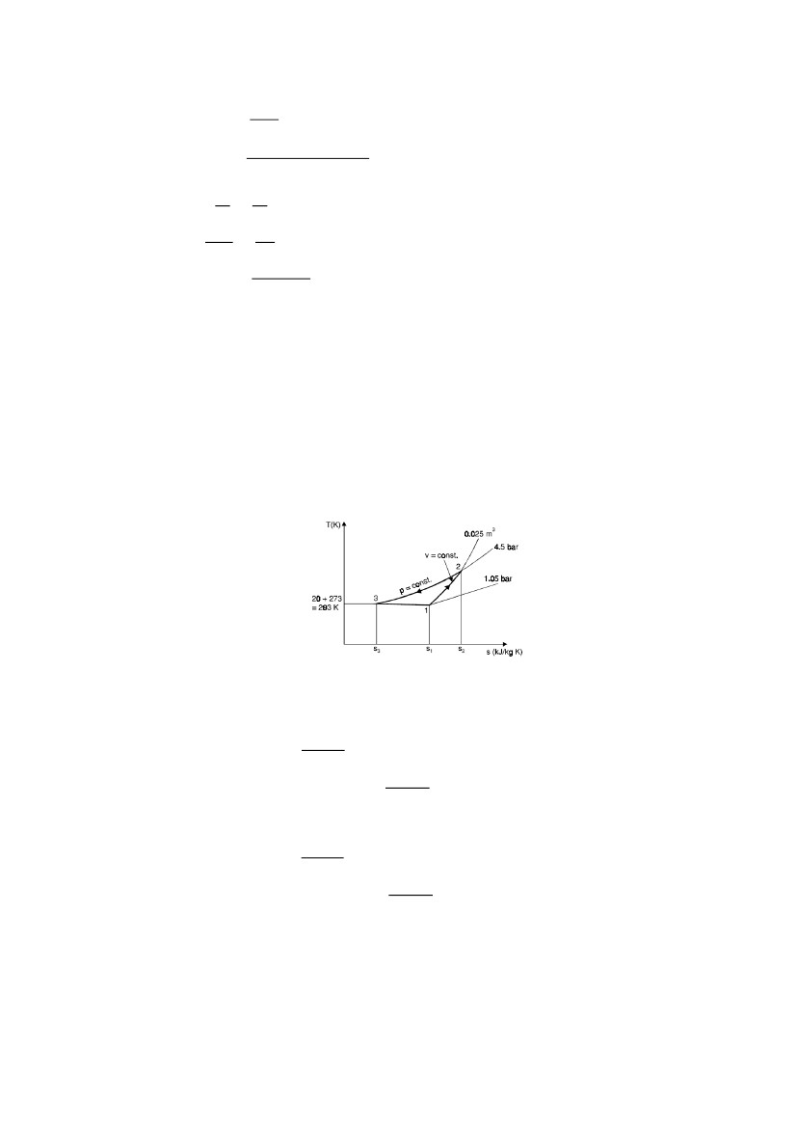
ME 2202 Engineering Thermodynamics Mechanical Engineering
For a perfect gas (corresponding to point 1 of air),
0
0 8
00
0
0 00
000
2012 - 2013
0
At constant volume,
Q = mcv (T2 – T1)
= 0.0312 × 0.718 (1255.7 – 293)
i.e., Q1–2 = 21.56 kJ.
Also, at constant pressure,
Q = m × cp × (T3 – T2)
= 0.0312 × 1.005 (293 – 1255.7)
i.e., Q2–3 = – 30.18 kJ
∴ Net heat flow = Q1–2 + Q2–3
= 21.56 + (– 30.18)
= – 8.62 kJ
i.e., Heat rejected = 8.62 kJ. (Ans.)
(ii) Net entropy change :
Net decrease in entropy,
S1 – S2 = (S2 – S3) – (S2 – S1)
At constant pressure, dQ = mcp dT, hence
(
(
)
)
∫
00
00
S2 – S3 = 0.0456 kJ/K
At constant volume, dQ = mcv dT, hence
(
(
)
)
∫
00
0
8
5.
S2 – S1 = 0.0326 kJ/K
∴ m(s1 – s3) = S1 – S3 = (S2 – S3) – (S2 – S1)
= 0.0456 – 0.0326
= 0.013 kJ/K
Hence, decrease in entropy = 0.013 kJ/K. (Ans.)
A reversible heat engine operates between two reservoirs at 827ºC and 27ºC. Engine drives a
Carnot refrigerator maintaining –13ºC and rejecting heat to reservoir at 27ºC. Heat input to the
engine is 2000 kJ and the net work available is 300 kJ. How much heat is transferred to
19

SK Engineering Academy
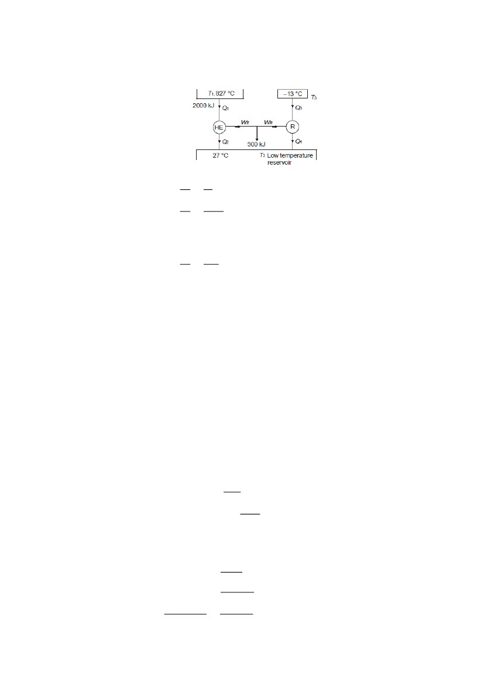
ME 2202 Engineering Thermodynamics Mechanical Engineering
refrigerant and total heat rejected to reservoir at 27ºC?
Solution:
Block diagram based on the arrangement stated;
2012 - 2013
We can write, for heat engine,
00
00
SubstitutingQ1 = 2000 kJ, we get Q2 = 545.45 kJ
Also WE = Q1 – Q2 = 1454.55 kJ
For refrigerator,
60
00
Also, WR= Q4 – Q3
and WE – WR = 300
or WR = 1154.55 kJ
From above equations,
Q4 – Q3 = 1154.55
From equations,
Q3 = 7504.58 kJ
Q4 = 8659.13 kJ
Total heat transferred to low temperature reservoir
= Q2 + Q4
= 9204.68 kJ
Heat transferred to refrigerant = 7504.58 kJ
Total heat transferred to low temperature reservoir = 9204.68 kJ Ans.
A heat pump is run by a reversible heat engine operating between reservoirs at 800°C and 50°C.
The heat pump working on Carnot cycle picks up 15 kW heat from reservoir at 10°C and
delivers it to a reservoir at 50°C. The reversible engine also runs a machine that needs 25 kW.
Determine the heat received from highest temperature reservoir and heat rejected to reservoir at
50°C.
Schematic arrangement for the problem is given in figure.
For heat engine,
6.
= 0.7246
For heat pump,
WHP = Q4 – Q3
= Q4 – 15
COP =
8
Q4 = 17.12 kW
SK Engineering Academy
20

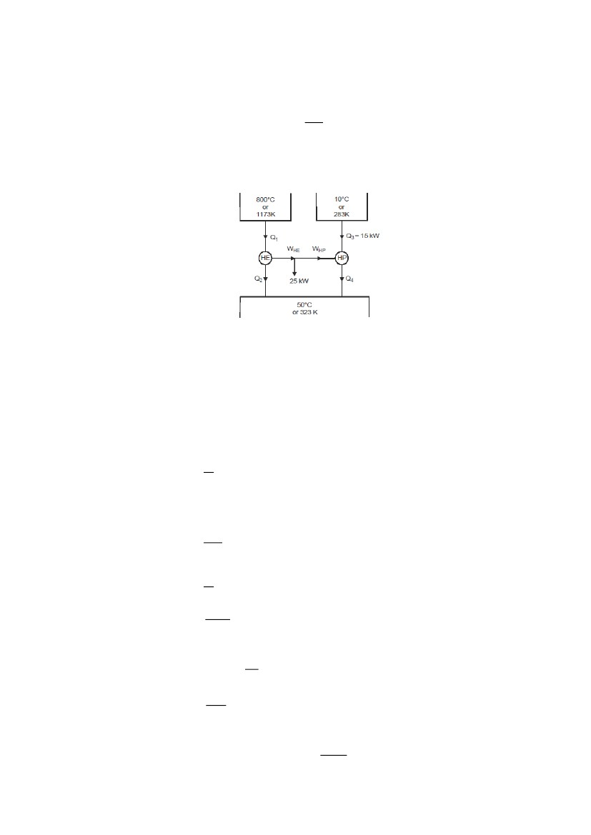
ME 2202 Engineering Thermodynamics Mechanical Engineering
WHP = 17.12 – 15
= 2.12 kW
Since, WHE = WHP + 25
WHE = 27.12 kW
ηHE = 0.7246 =
Q1 = 37.427 kW
Q2 = Q1 – WHE
= 37.427 – 27.12
Q2 = 10.307 kW
2012 - 2013
7.
Hence heat rejected to reservoir at 50°C
= Q2 + Q4
= 10.307 + 17.12
= 27.427 kW Ans.
Heat received from highest temperature reservoir = 37.427kW Ans.
Find the change in entropy of steam generated at 400ºC from 5 kg of water at 27ºC and
atmospheric pressure. Take specific heat of water to be 4.2 kJ/kg.K, heat of vaporization at
100ºC as 2260 kJ/kg and specific heat for steam given by; cp = R (3.5 + 1.2T + 0.14T2), J/kg.K
Solution:
Total entropy change = Entropy change during water temperature rise (ΔS1) + Entropy change
during water to steam change (ΔS2) + Entropy change during steam temperature rise (ΔS3)
ΔS1 =
where Q1 = m cp ΔT
Heat added for increasing water temperature from 27ºC to 100ºC.
= 5 × 4.2 × (100 – 27)
= 1533 kJ
ΔS1 =
= 5.11 kJ/K
Entropy change during phase transformation;
ΔS2 =
Here Q2 = Heat of vaporization = 5 × 2260 = 11300 kJ
Entropy change, ΔS2=
= 30.28 kJ/K.
Entropy change during steam temperature rise;
∫
For steam
Therefore,
Here dQ = mcp dT
R== 0.462 kJ/kg.K
cp for steam = 0.462 (3.5 + 1.2 · T + 0.14T2) × 10–3
= (1.617 + 0.5544 T + 0.065 T2) × 10–3
6
∫0(0
= 51843.49 × 10–3 kJ/K
21
0 06
)

SK Engineering Academy

ME 2202 Engineering Thermodynamics Mechanical Engineering
2012 - 2013
8.
ΔS3 = 51.84 kJ/K
Total entropy change = 5.11 + 30.28 + 51.84
= 87.23 kJ/K Ans.
Determine the change in entropy of universe if a copper block of 1 kg at 150ºC is placed in a sea
water at 25ºC. Take heat capacity of copper as 0.393 kJ/kg K.
Entropy change in universe
ΔSuniverse = ΔSblock + ΔSwater
where ΔSblock = mC. ln
Here hot block is put into sea water, so block shall cool down upto sea water at 25ºC as sea may
be treated as sink.
Therefore, T1 = 150ºC or 423.15 K
andT2 = 25ºC or 298.15 K
where ΔSblock = 1 X 0.393 x ln ()
= – 0.1376 kJ/K
Heat lost by block = Heat gained by water
= – 1 × 0.393 × (423.15 – 298.15)
= – 49.125 kJ
Therefore, ΔSwater =
= 0.165 kJ/k
Thus, ΔSuniverse = – 0.1376 + 0.165
= 0.0274 kJ/k or 27.4 J/K
Entropy change of universe = 27.4 J/K Ans.
Two tanks A and B are connected through a pipe with valve in between. Initially valve is closed
and tanks A and B contain 0.6 kg of air at 90°C, 1 bar and 1 kg of air at 45°C, 2 bar respectively.
Subsequently valve is opened and air is allowed to mix until equilibrium. Considering the
complete system to be insulated determine the final temperature, final pressure and entropy
change.
In this case due to perfectly insulated system, Q = 0, Also W = 0
Let the final state be given by subscript f ′ and initial states of tank be given by subscripts ‘A’
and ‘B’. pA = 1 bar, TA = 363 K, mA = 0.6 kg; TB = 318K, mB = 1kg, pB = 2 bar
ΔQ = ΔW + ΔU
0 = 0 + {(mA + mB) + Cv.Tf – (mA.CvTA) – (mB.Cv.TB)}
()
()
(0 668)
(0 6)
Tf = 334.88 K,
Final temperature = 334.88 K Ans.
Using gas law for combined system after attainment of equilibrium,
()
()
9.
VA = 0.625 m3
VB = 0.456 m3
(0 6) 0 888
(0 60 6)
= 142.25 kPa
Final pressure = 142.25 kPa Ans.
Entropy change;
ΔS = {((mA + mB).sf) – (mA.sA + mBsB)}
ΔS = {mA(sf – sA) + mB (sf – sB)}
SK Engineering Academy
22


ME 2202 Engineering Thermodynamics Mechanical Engineering
{
(
)
(
)}
2012 - 2013
Considering Cp = 1.005 kJ/kg.K
0 8)( 000 8)}{0 6 ( 00
ΔS = { – 0.1093 + 014977}
= 0.04047 kJ/K
Entropy produced = 0.04047 kJ/K Ans.
10. Explain Carnot cycle with neat sketches.
We mentioned earlier that heat engines are cyclic devices and that the working fluid of a heat
engine returns to its initial state at the end of each cycle. Work is done by the working fluid
during one part of the cycle and on the working fluid during another part. The difference
between these two is the net work delivered by the heat engine. The efficiency of a heat-engine
cycle greatly depends on how the individual processes that make up the cycle are executed. The
net work, thus the cycle efficiency, can be maximized by using processes that require the least
amount of work and deliver the most, that is, by using reversible processes. Therefore, it is no
surprise that the most efficient cycles are reversible cycles, that is, cycles that consist entirely of
reversible processes. Reversible cycles cannot be achieved in practice because the
irreversibilities associated with each process cannot be eliminated. However, reversible cycles
provide upper limits on the performance of real cycles. Heat engines and refrigerators that work
on reversible cycles serve as models to which actual heat engines and refrigerators can be
compared. Reversible cycles also serve as starting points in the development of actual cycles and
are modified as needed to meet certain requirements. Probably the best known reversible cycle is
the Carnot cycle, first proposed in 1824 by French engineer Sadi Carnot. The theoretical heat
engine that operates on the Carnot cycle is called the Carnot heat engine. The Carnot cycle is
composed of four reversible processes—two isothermal and two adiabatic—and it can be
executed either in a closed or a steady-flow system.
Consider a closed system that consists of a gas contained in an adiabatic piston–cylinder device,
as shown in figure. The insulation of the cylinder head is such that it may be removed to bring
the cylinder into contact with reservoirs to provide heat transfer. The four reversible processes
that make up the Carnot cycle are as follows:
Reversible Isothermal Expansion (process 1-2, TH = constant).
Initially (state 1), the temperature of the gas is T H and the cylinder head is in close contact with a
source at temperature TH. The gas is allowed to expand slowly, doing work on the surroundings.
As the gas expands, the temperature of the gas tends to decrease. But as soon as the temperature
drops by an infinitesimal amount dT, some heat is transferred from the reservoir into the gas,
raising the gas temperature to TH. Thus, the gas temperature is kept constant at TH. Since the
temperature difference between the gas and the reservoir never exceeds a differential amount dT,
this is a reversible heat transfer process. It continues until the piston reaches position 2. The
amount of total heat transferred to the gas during this process is QH.
Reversible Adiabatic Expansion (process 2-3, temperature drops from TH to TL).
At state 2, the reservoir that was in contact with the cylinder head is removed and replaced by
insulation so that the system becomes adiabatic. The gas continues to expand slowly, doing work
on the surroundings until its temperature drops from TH to TL (state 3). The piston is assumed to
be frictionless and the process to be quasi-equilibrium, so the process is reversible as well as
adiabatic.
Reversible Isothermal Compression (process 3-4, TL = constant).
At state 3, the insulation at the cylinder head is removed, and the cylinder is brought into contact
with a sink at temperature TL. Now the piston is pushed inward by an external force, doing work
on the gas. As the gas is compressed, its temperature tends to rise. But as soon as it rises by an
infinitesimal amount dT, heat is transferred from the gas to the sink, causing the gas temperature
to drop to TL. Thus, the gas temperature remains constant at TL. Since the temperature difference
between the gas and the sink never exceeds a differential amount dT, this is a reversible heat
transfer process. It continues until the piston reaches state 4. The amount of heat rejected from
the gas during this process is QL.
Reversible Adiabatic Compression (process 4-1, temperature rises from TL to TH).
State 4 is such that when the low-temperature reservoir is removed, the insulation is put back on
SK Engineering Academy
23

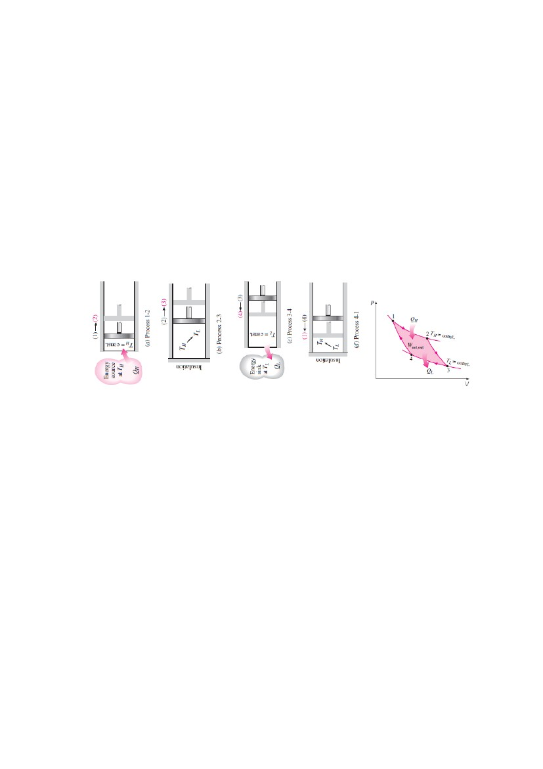
ME 2202 Engineering Thermodynamics Mechanical Engineering
2012 - 2013
the cylinder head, and the gas is compressed in a reversible manner, the gas returns to its initial
state (state 1). The temperature rises from TL to TH during this reversible adiabatic compression
process, which completes the cycle.
The P-V diagram of this cycle is shown in figure. Remembering that on a P-V diagram the area
under the process curve represents the boundary work for quasi-equilibrium (internally
reversible) processes, we see that the area under curve 1-2-3 is the work done by the gas during
the expansion part of the cycle, and the area under curve 3-4-1 is the work done on the gas
during the compression part of the cycle. The area enclosed by the path of the cycle (area 1-2-3-
4-1) is the difference between these two and represents the net work done during the cycle.
Notice that if we acted stingily and compressed the gas at state 3 adiabatically instead of
isothermally in an effort to save QL, we would end up back at state 2, retracing the process path
3-2. By doing so we would save QL, but we would not be able to obtain any net work output
from this engine. This illustrates once more the necessity of a heat engine exchanging heat with
at least two reservoirs at different temperatures to operate in a cycle and produce a net amount of
work.
The Carnot cycle can also be executed in a steady-flow system. Being a reversible cycle, the
Carnot cycle is the most efficient cycle operating between two specified temperature limits. Even
though the Carnot cycle cannot be achieved in reality, the efficiency of actual cycles can be
improved by attempting to approximate the Carnot cycle more closely.
UNIT III
Properties of Pure substance and Steam power cycles
2 Marks
1. Why Rankine cycle is modified?
The work obtained at the end of the expansion is very less. The work is too inadequate to overcome
the friction. Therefore the adiabatic expansion is terminated at the point before the end of the
expansion in the turbine and pressure decreases suddenly, while the volume remains constant.
2. Name the various vapour power cycle.
Carnot cycle and Rankine cycle.
3. Define efficiency ratio.
The ratio of actual cycle efficiency to that of the ideal cycle efficiency is termed as efficiency ratio.
4. Define overall efficiency.
It is the ratio of the mechanical work to the energy supplied in the fuel. It is also defined as the product
of combustion efficiency and the cycle efficiency.
5. Define specific steam consumption of an ideal Rankine cycle.
It is defined as the mass flow of steam required per unit power output.
6. Name the different components in steam power plant working on Rankine cycle.
Boiler, Turbine, Cooling Tower or Condenser and Pump.
7. What are the effects of condenser pressure on the Rankine Cycle?
By lowering the condenser pressure, we can increase the cycle efficiency. The main disadvantage is
lowering the back pressure in release the wetness of steam. Isentropic compression of a very wet
vapour is very difficult.
8. Mention the improvements made to increase the ideal efficiency of Rankine cycle.
1. Lowering the condenser pressure.
2. Superheated steam is supplied to the turbine.
3. Increasing the boiler pressure to certain limit.
4. Implementing reheat and regeneration in the cycle.
SK Engineering Academy
24

ME 2202 Engineering Thermodynamics Mechanical Engineering
2012 - 2013
9. Why reheat cycle is not used for low boiler pressure?
At the low reheat pressure the heat cycle efficiency may be less than the Rankine cycle efficiency.
Since the average temperature during heating will then be low.
10. What are the disadvantages of reheating?
Reheating increases the condenser capacity due to increased dryness fraction, increases the cost of the
plant due to the reheats and its very long connections.
11. What are the advantages of reheat cycle?
1. It increases the turbine work.
2. It increases the heat supply.
3. It increases the efficiency of the plant.
4. It reduces the wear on the blade because of low moisture content in LP state of the turbine.
12. Define latent heat of evaporation or Enthalpy of evaporation.
The amount of heat added during heating of water up to dry steam from boiling point is known as
Latent heat of evaporation or enthalpy of evaporation.
13. Explain the term super heated steam and super heating.
The dry steam is further heated its temperature raises, this process is called as superheating and the
steam obtained is known as superheated steam.
14. Explain heat of super heat or super heat enthalpy.
The heat added to dry steam at 100oC to convert it into super heated steam at the temperature Tsup is
called as heat of superheat or super heat enthalpy.
15. Explain the term critical point, critical temperature and critical pressure.
In the T-S diagram the region left of the waterline, the water exists as liquid. In right of the dry steam
line, the water exists as a super heated steam. In between water and dry steam line the water exists as a
wet steam. At a particular point, the water is directly converted into dry steam without formation of
wet steam. The point is called critical point. The critical temperature is the temperature above which a
substance cannot exist as a liquid; the critical temperature of water is 374.15oC. The corresponding
pressure is called critical pressure.
16. Define dryness fraction (or) What is the quality of steam?
It is defined as the ratio of mass of the dry steam to the mass of the total steam.
17. Define enthalpy of steam.
It is the sum of heat added to water from freezing point to saturation temperature and the heat
absorbed during evaporation.
18. How do you determine the state of steam?
If V>vg then super-heated steam, V= vg then dry steam and V< vg then wet steam.
19. Define triple point.
The triple point is merely the point of intersection of sublimation and vapourisation curves.
20. Define heat of vapourisation.
The amount of heat required to convert the liquid water completely into vapour under this condition is
called the heat of vapourisation.
21. Explain the terms, Degree of super heat, degree of sub-cooling.
The difference between the temperature of the superheated vapour and the saturation temperature at
the same pressure. The temperature between the saturation temperature and the temperature in the sub
cooled region of liquid.
22. What is the purpose of reheating?
The purpose of reheating is to increase the dryness fraction of the steam passing out of the later stages
of the turbine.
23. What are the processes that constitute a Rankine cycle?
Process 1–2: Isentropic expansion of the working fluid through the turbine from saturated vapor at
state 1 to the condenser pressure.
Process 2–3: Heat transfer from the working fluid as it flows at constant pressure through the
condenser with saturated liquid at state 3.
Process 3–4: Isentropic compression in the pump to state 4 in the compressed liquid region.
Process 4–1: Heat transfer to the working fluid as it flows at constant pressure through the boiler to
complete the cycle.
SK Engineering Academy
25


ME 2202 Engineering Thermodynamics Mechanical Engineering
2012 - 2013
16 Marks
1.
A vessel having a capacity of 0.05 m contains a mixture of saturated water and saturated steam
at a temperature of 245°C. The mass of the liquid present is 10 kg. Find the following :
(i) The pressure, (ii) The mass, (iii) The specific volume, (iv) The specific enthalpy, (v) The
specific entropy, and (vi) The specific internal energy.
From steam tables, corresponding to 245°C :
psat = 36.5 bar,
vf = 0.001239 m3/kg,
vg = 0.0546 m3/kg
hf = 1061.4 kJ/kg,
hfg = 1740.2 kJ/kg,
sf = 2.7474 kJ/kg K
sfg = 3.3585 kJ/kg K.
(i) The pressure= 36.5 bar (or 3.65 MPa). (Ans.)
(ii) The mass, m :
Volume of liquid, Vf = mfvf
= 10 × 0.001239
= 0.01239 m3
Volume of vapour, Vg = 0.05 – 0.01239
= 0.03761 m3
∴ Mass of vapour,
00 6
00 6
= 0.688 kg
∴ The total mass of mixture,
m = mf + mg
= 10 + 0.688
= 10.688 kg. (Ans.)
(iii) The specific volume, v :
Quality of the mixture,
0 688
0 6880
0 06
v = vf + x vfg
= 0.001239 + 0.064 × (0.0546 – 0.001239)(Since vfg = vg − vf )
3
= 0.004654 m /kg. (Ans.)
(iv) The specific enthalpy, h :
h = hf + x hfg
= 1061.4 + 0.064 × 1740.2
= 1172.77 kJ/kg. (Ans.)
(v) The specific entropy, s :
s = sf + x sfg
= 2.7474 + 0.064 × 3.3585
= 2.9623 kJ/kg K. (Ans.)
(vi) The specific internal energy, u :
u = h – pv
= 1155.78 kJ/kg.
A pressure cooker contains 1.5 kg of saturated steam at 5 bar. Find the quantity of heat which
must be rejected so as to reduce the quality to 60% dry. Determine the pressure and temperature
of the steam at the new state.
Solution. Mass of steam in the cooker= 1.5 kg
Pressure of steam,p = 5 bar
Initial dryness fraction of steam, x1 = 1
Final dryness fraction of steam, x2 = 0.6
26

3
2.
SK Engineering Academy

ME 2202 Engineering Thermodynamics Mechanical Engineering
2012 - 2013
3.
Heat to be rejected :
Pressure and temperature of the steam at the new state :
At 5 bar. From steam tables,
ts = 151.8°C ;
hf = 640.1 kJ/kg ;
hfg = 2107.4 kJ/kg ;
vg = 0.375 m3/kg
Thus, the volume of pressure cooker
= 1.5 × 0.375
= 0.5625 m3
Internal energy of steam per kg at initial point 1,
u1 = h1 – p1v1
= (hf + hfg) – p1vg1(Since v1 = vg1)
5–3= (640.1 + 2107.4) – 5 × 10 × 0.375 × 10
= 2747.5 – 187.5
= 2560 kJ/kg
Also, V1 = V2 (V2 = volume at final condition)
i.e., 0.5625 = 1.5[(1 – x2) vf2 + x2vg2]
= 1.5 x2vg2(Since vf 2 is negligible)
= 1.5 × 0.6 × vg2
0 6
06
06
From steam tables corresponding to 0.625 m3/kg,
p2 ~ 2.9 bar,
ts = 132.4°C,
hf = 556.5 kJ/kg,
hfg = 2166.6 kJ/kg
Internal energy of steam per kg, at final point 2,
u2 = h2 – p2v2
= (hf2 + x2hfg2) – p2xvg2(Since, v2 = x vg 2)
= (556.5 + 0.6 × 2166.6) – 2.9 × 105 × 0.6 × 0.625 × 10–3
= 1856.46 – 108.75
= 1747.71 kJ/kg.
Heat transferred at constant volume per kg
= u2 – u1
= 1747.71 – 2560
= – 812.29 kJ/kg
Thus, total heat transferred
= – 812.29 × 1.5
= – 1218.43 kJ. (Ans.)
Negative sign indicates that heat has been rejected.
A spherical vessel of 0.9 m3 capacity contains steam at 8 bar and 0.9 dryness fraction. Steam is
blown off until the pressure drops to 4 bar. The valve is then closed and the steam is allowed to
cool until the pressure falls to 3 bar. Assuming that the enthalpy of steam in the vessel remains
constant during blowing off periods, determine :
(i) The mass of steam blown off ;
(ii) The dryness fraction of steam in the vessel after cooling ;
(iii) The heat lost by steam per kg during cooling.
Solution. Capacity of the spherical vessel, V = 0.9 m3
Pressure of the steam,p1 = 8 bar
Dryness fraction of steam,x1 = 0.9
Pressure of steam after blow off, p2 = 4 bar
Final pressure of steam,p3 = 3 bar.
(i) The mass of steam blown off :
The mass of steam in the vessel
SK Engineering Academy
27


ME 2202 Engineering Thermodynamics Mechanical Engineering
0
0
6
0
(
8
0
)
2012 - 2013
The enthalpy of steam before blowing off (per kg)
= hf1 + x1hfg1 = 720.9 + 0.9 × 2046.5 ...... at pressure 8 bar
= 2562.75 kJ/kg
Enthalpy before blowing off = Enthalpy after blowing off
∴ 2562.75 = (hf2 + x2hfg2) at pressure 4 bar
= 604.7 + x2 × 2133 ...... at pressure 4 bar
660
0 8
Now the mass of steam in the vessel after blowing off,
0
0 8 0 6
[vg2 = 0.462 m3 / kg.......at 4 bar]
Mass of steam blown off, m = m1 – m2
= 4.167 – 2.122
= 2.045 kg. (Ans.)
(ii) Dryness fraction of steam in the vessel after cooling, x3 :
As it is constant volume cooling
∴ x2vg2 (at 4 bar) = x3vg3 (at 3 bar)
0.918 × 0.462 = x3 × 0.606
0 80 6
0 606
06
(iii) Heat lost during cooling :
Heat lost during cooling = m (u3 – u2), where u2 and u3 are the internal energies of steam before
starting cooling or after blowing and at the end of the cooling.
∴ u2 = h2 – p2x2vg2
= (hf2 + x2hfg2) – p2x2vg2
= (604.7 + 0.918 × 2133) – 4 × 105 × 0.918 × 0.462 × 10–3
= 2562.79 – 169.65
= 2393.14 kJ/kg
u3 = h3 – p3x3vg3
= (hf3 + x3hfg3) – p3x3vg3
= (561.4 + 0.669 × 2163.2) – 3 × 105 × 0.699 × 0.606 × 10–3
= 2073.47 – 127.07
= 1946.4 kJ/kg
∴ Heat transferred during cooling
= 2.045 (1946.4 – 2393.14)
= – 913.6 kJ.
i.e., Heat lost during cooling = 913.6 kJ. (Ans.)
Calculate the internal energy per kg of superheated steam at a pressure of 10 bar and a
temperature of 300°C. Also find the change of internal energy if this steam is expanded to 1.4
bar and dryness fraction 0.8.
Solution. At 10 bar, 300°C. From steam tables for superheated steam.
hsup = 3051.2 kJ/kg (Tsup = 300 + 273 = 573 K)
28

4.
SK Engineering Academy
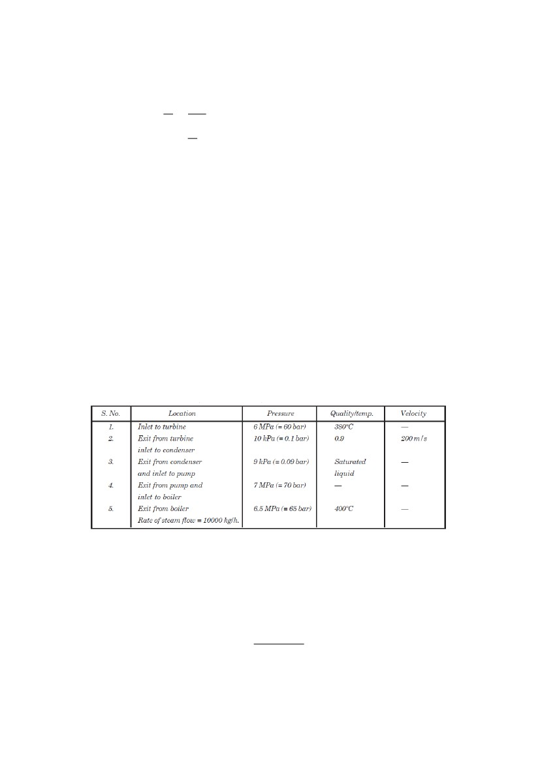
ME 2202 Engineering Thermodynamics Mechanical Engineering
and corresponding to 10 bar (from tables of dry saturated steam)
Ts = 179.9 + 273 = 452.9 K ;
vg = 0.194 m3/kg
To find vsup., using the relation,
2012 - 2013
5.
= 0.245 m3/kg.
Internal energy of superheated steam at 10 bar,
u1 = hsup – pvsup
= 3051.2 – 10 × 105 × 0.245 × 10–3
= 2806.2 kJ/kg. (Ans.)
At 1.4 bar. From steam tables ;
hf = 458.4 kJ/kg,
hfg = 2231.9 kJ/kg ;
vg = 1.236 m3/kg
Enthalpy of wet steam (after expansion)
h = hf + x hfg
= 458.4 + 0.8 × 2231.9
= 2243.92 kJ.
Internal energy of this steam,
u2 = h – pxvg
= 2243.92 – 1.4 × 105 × 0.8 × 1.236 × 10–3
= 2105.49 kJ
Hence change of internal energy per kg
u2 – u1 = 2105.49 – 2806.2
= – 700.7 kJ. (Ans.)
Negative sign indicates decrease in internal energy.
The following data refer to a simple steam power plant :
Calculate :
(i) Power output of the turbine.
(ii) Heat transfer per hour in the boiler and condenser separately.
(iii) Mass of cooling water circulated per hour in the condenser. Choose the inlet temperature of
cooling water 20°C and 30°C at exit from the condenser.
(iv) Diameter of the pipe connecting turbine with condenser.
Solution.
(i) Power output of the turbine, P :
At 60 bar, 380°C : From steam tables,
0 0(0 )0...By interpolation
()
= 3123.5 kJ/kg
At 0.1 bar :
hf2 = 191.8 kJ/kg,
hfg2 = 2392.8 kJ/kg (from steam tables)
and x2 = 0.9 (given)
SK Engineering Academy
29

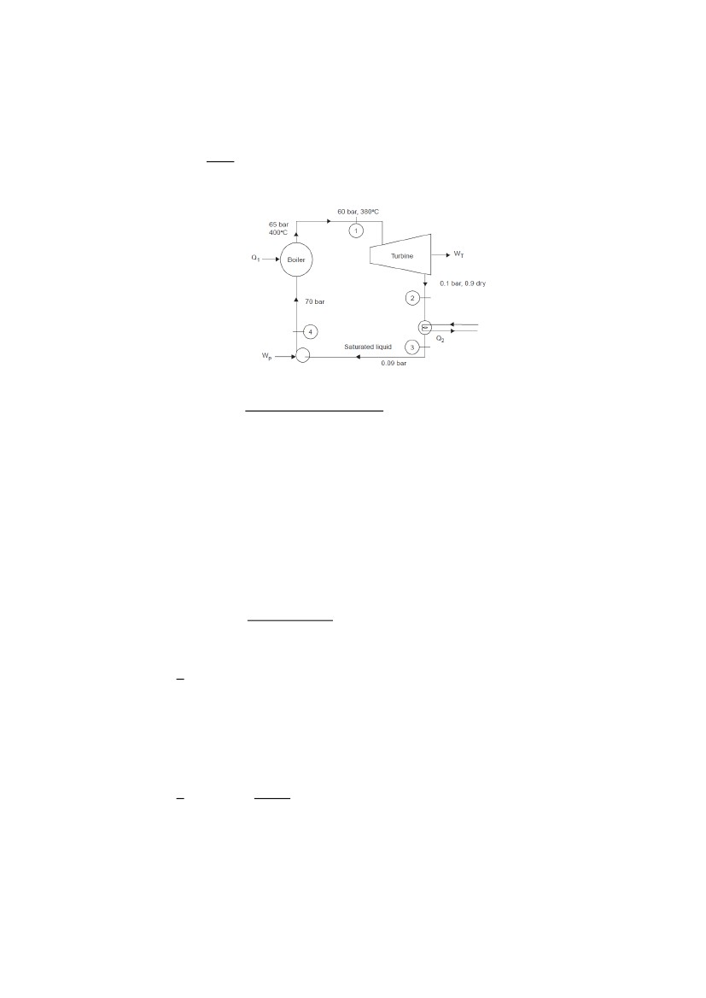
ME 2202 Engineering Thermodynamics Mechanical Engineering
∴ h2 = hf2 + x2 hfg2
= 191.8 + 0.9 × 2392.8
= 2345.3 kJ/kg
Power output of the turbine = ms (h1 – h2) kW,
[where ms = Rate of steam flow in kg/s and h1, h2 = Enthalpy of steam in kJ/kg]
(8)
6
Hence power output of the turbine = 2162 kW. (Ans.)
2012 - 2013
(ii) Heat transfer per hour in the boiler and condenser :
At 70 bar : hf4 = 1267.4 kJ/kg
()()
At 65 bar, 400°C :(
= 3167.6 kJ/kg
∴ Heat transfer per hour in the boiler,
Q1 = 10000 (ha – hf4 ) kJ/h
= 10000 (3167.6 – 1267.4) = 1.9 × 107 kJ/h. (Ans.)
At 0.09 bar : hf3 = 183.3 kJ/kg
Heat transfer per hour in the condenser,
Q1 = 10000 (h2 − hf3)
= 10000 (2345.3 – 183.3) = 2.16 × 107 kJ/h. (Ans.)
(iii) Mass of cooling water circulated per hour in the condenser, mw :
Heat lost by steam = Heat gained by the cooling water
Q2 = mw × cpw (t2 – t1)
2.16 × 107 = mw × 4.18 (30 – 20)
60
8( 00)
7
= 1.116 × 10 kg/h. (Ans.)
(iv) Diameter of the pipe connecting turbine with condenser, d :
)
6.
Here, d = Diameter of the pipe (m),
C = Velocity of steam = 200 m/s (given),
ms = Mass of steam in kg/s,
x2 = Dryness fraction at ‘2’, and
vg2 = Specific volume at pressure 0.1 bar (= 14.67 m3/kg).
Substituting the various values in eqn. (i), we get
0000
0006
600
d =0.483 m or 483 mm. (Ans.)
In a steam turbine steam at 20 bar, 360°C is expanded to 0.08 bar. It then enters a condenser,
where it is condensed to saturated liquid water. The pump feeds back the water into the boiler.
Assume ideal processes, find per kg of steam the net work and the cycle efficiency.
Solution. Boiler pressure,p1 = 20 bar (360°C)
Condenser pressure, p2 = 0.08 bar
From steam tables :
At 20 bar (p1), 360°C :h1 = 3159.3 kJ/kg
30

SK Engineering Academy
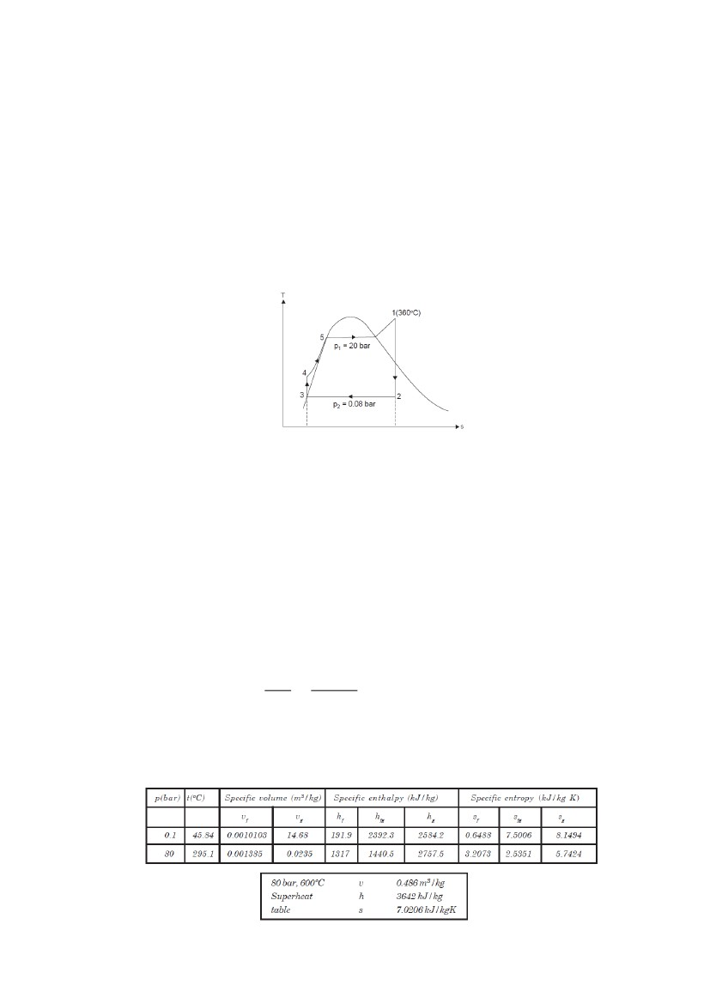
ME 2202 Engineering Thermodynamics Mechanical Engineering
s1 = 6.9917 kJ/kg-K
At 0.08 bar (p2) :h3 = hf (p2) = 173.88 kJ/kg,
s3 = sf (p2) = 0.5926 kJ/kg-K
hfg (p2) = 2403.1 kJ/kg
sg (p2) = 8.2287 kJ/kg-K
vf (p2) = 0.001008 m3/kg
∴ sfg (p2) = 7.6361 kJ/kg-K
Now s1 = s2
6.9917 = sf (p2) + x2 sfg (p2)
= 0.5926 + x2 × 7.6361
x2 = 0.838
h2 = hf (p2) + x2 hfg (p2)
= 173.88 + 0.838 × 2403.1
= 2187.68 kJ/kg.
2012 - 2013
Net work, Wnet :
7.
Wnet = Wturbine – Wpump
Wpump = hf4 – hf (p2) (= hf3 )
= vf (p2) (p1 – p2)
= 0.00108 (m3/kg) × (20 – 0.08) × 100 kN/m2
= 2.008 kJ/kg
[and hf4 = 2.008 + hf (p2) = 2.008 + 173.88 = 175.89 kJ/kg]
Wturbine = h1 – h2
= 3159.3 – 2187.68
= 971.62 kJ/kg
∴ Wnet = 971.62 – 2.008
= 969.61 kJ/kg. (Ans.)
Cycle efficiency, ηcycle :
Q1 = h1 – hf4
= 3159.3 – 175.89
= 2983.41 kJ/kg
6 6
∴
8
= 0.325 or 32.5%. (Ans.)
A Rankine cycle operates between pressures of 80 bar and 0.1 bar. The maximum cycle
temperature is 600°C. If the steam turbine and condensate pump efficiencies are 0.9 and 0.8
respectively, calculate the specific work and thermal efficiency. Relevant steam table extract is
given below.
SK Engineering Academy
31

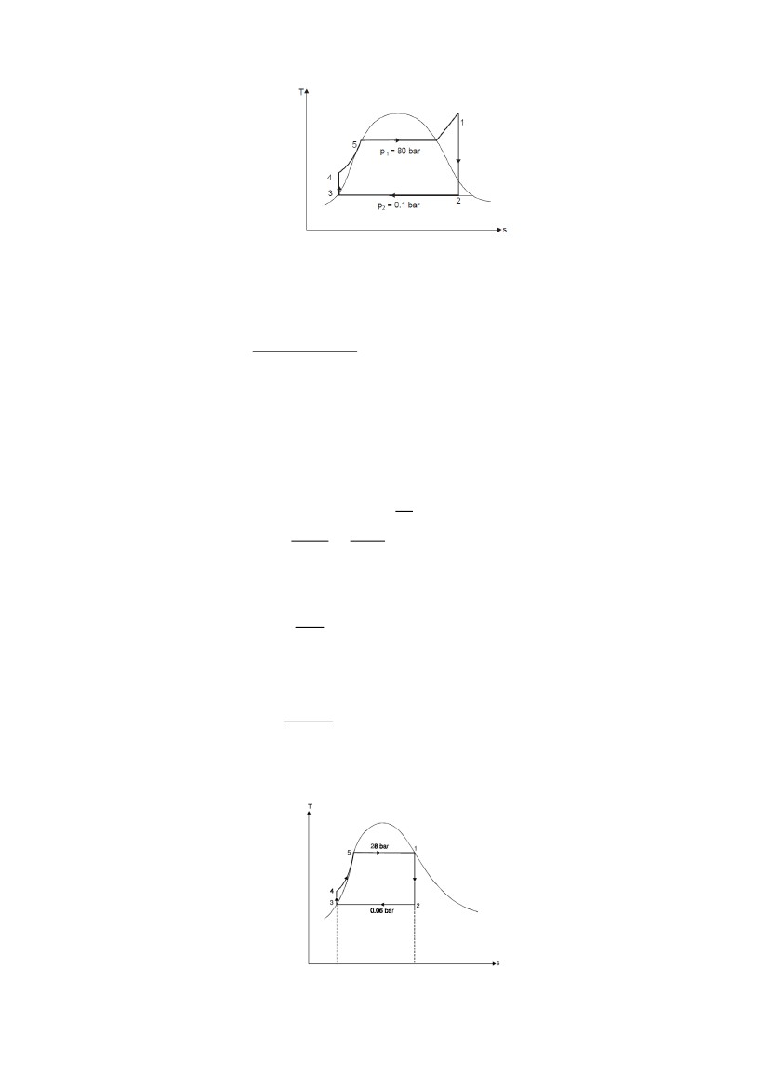
ME 2202 Engineering Thermodynamics Mechanical Engineering
2012 - 2013
At 80 bar, 600ºC :
h1 = 3642 kJ / kg ;
s1 = 7.0206 kJ / kg K.
Since s1 = s2,
∴ 7.0206 = sf2 + x2 sfg2
= 0.6488 + x2 × 7.5006
0 06 0 6 88
006
= 0.85
Now, h2 = hf2 + x2 hfg2
= 191.9 + 0.85 × 2392.3
= 2225.36 kJ/kg
Actual turbine work
= ηturbine × (h1 − h2 )
= 0.9 (3642 – 2225.36)= 1275 kJ/kg
Pump work = vf ( p2 )( p1 − p2 )
0 00 0 0 (80 – 0 )
8080
08
= 10.09 kJ/kg
Specific work (Wnet ) = 1275 – 10.09
= 1264.91 kJ / kg. (Ans.)
80
8.
where, Q1 = h1 – hf4
But hf4 = hf3 + pump work
= 191.9 + 10.09
= 202 kJ/kg
∴ Thermal efficiency, ηth =
= 0.368 or 36.8 %. (Ans.)
A simple Rankine cycle works between pressures 28 bar and 0.06 bar, the initial condition of
steam being dry saturated. Calculate the cycle efficiency, work ratio and specific steam
consumption.
From steam tables,
At 28 bar :
h1 = 2802 kJ/kg,
s1 = 6.2104 kJ/kg K
32

SK Engineering Academy

ME 2202 Engineering Thermodynamics Mechanical Engineering
At 0.06 bar : hf2 = hf3 = 151.5 kJ/kg,
hfg2 = 2415.9 kJ/kg,
sf2 = 0.521 kJ/kg K,
sfg2 = 7.809 kJ/kg K
vf = 0.001 m3/kg
Considering turbine process 1-2, we have :
s1 = s 2
6.2104 = sf2 + x2 sfg2
= 0.521 + x2 × 7.809
x2 = 0.728
h2 = hf2 + x2 hfg2
= 151.5 + 0.728 × 2415.9
= 1910.27 kJ/kg
∴ Turbine work, Wturbine = h1 – h2
= 2802 – 1910.27
= 891.73 kJ/kg
Pump work, Wpump = hf4 – hf3
= vf (p1 – p2)
0 00 ( 8 0 06) 0
000
= 2.79 kJ/kg
[Since, hf4 = hf3 + 2.79 = 151.5 + 2.79 = 154.29 kJ/kg]
∴ Net work, Wnet = Wturbine – Wpump
= 891.73 – 2.79
= 888.94 kJ/kg
Cycle efficiency
888
888
80
= 0.3357 or 33.57%. (Ans.)
888
8
= 0.997. (Ans.)
Specific steam consumption =
9.
2012 - 2013
= 4.049 kg/kWh.
In a Rankine cycle, the steam at inlet to turbine is saturated at a pressure of 35 bar and the
exhaust pressure is 0.2 bar. Determine :
(i) The pump work, (ii) The turbine work, (iii) The Rankine efficiency, (iv) The condenser heat
flow, (v) The dryness at the end of expansion. Assume flow rate of 9.5 kg/s.
Solution. Pressure and condition of steam, at inlet to the turbine,
p1 = 35 bar, x = 1
Exhaust pressure, p2 = 0.2 bar
Flow rate,̇ = 9.5 kg/s
SK Engineering Academy
33


ME 2202 Engineering Thermodynamics Mechanical Engineering
2012 - 2013
From steam tables :
At 35 bar : h1 = hg1 = 2802 kJ/kg,
sg1 = 6.1228 kJ/kg K
At 0.26 bar : hf = 251.5 kJ/kg,
hfg = 2358.4 kJ/kg,
vf = 0.001017 m3/kg,
sf = 0.8321 kJ/kg K,
sfg = 7.0773 kJ/kg K.
(i) The pump work :
Pump work = (p4 – p3) vf
= (35 – 0.2) × 105 × 0.001017 J or 3.54 kJ/kg
Also hf4 – hf3 = Pump work = 3.54 kJ/kg
∴ hf4 = 251.5 + 3.54
= 255.04 kJ/kg
Now power required to drive the pump
= 9.5 × 3.54 kJ/s or 33.63 kW. (Ans.)
(ii) The turbine work :
s1 = s2 = sf2 + x2 × sfg2
6.1228 = 0.8321 + x2 × 7.0773
x2 = 0.747
∴ h2 = hf2 + x2 hfg2
= 251.5 + 0.747 × 2358.4
= 2013 kJ/kg
∴ Turbine work = ̇ (h1 – h2)
= 9.5 (2802 – 2013)
= 7495.5 kW. (Ans.)
It may be noted that pump work (33.63 kW) is very small as compared to the turbine work
(7495.5 kW).
(iii) The Rankine efficiency :
800
80
= 0.3093 or 30.93%. (Ans.)
(iv) The condenser heat flow :
The condenser heat flow = ̇ (h2 – hf3 )
= 9.5 (2013 – 251.5)
= 16734.25 kW. (Ans.)
(v) The dryness at the end of expansion, x2 :
The dryness at the end of expansion,
x2 = 0.747 or 74.7%. (Ans.)
10. A steam turbine is fed with steam having an enthalpy of 3100 kJ/kg. It moves out of the turbine
with an enthalpy of 2100 kJ/kg. Feed heating is done at a pressure of 3.2 bar with steam enthalpy
of 2500 kJ/kg. The condensate from a condenser with an enthalpy of 125 kJ/kg enters into the
feed heater. The quantity of bled steam is 11200 kg/h. Find the power developed by the turbine.
Assume that the water leaving the feed heater is saturated liquid at 3.2 bar and the heater is direct
mixing type. Neglect pump work.
At 3.2 bar, hf2 = 570.9 kJ/kg.
Consider m kg out of 1 kg is taken to the feed heater
Energy balance for the feed heater is written as :
mh2 + (1 – m) hf5 = 1 × hf2
m × 2100 + (1 – m) × 125 = 1 × 570.9
2100 m + 125 – 125 m = 570.9
1975 m = 570.9 – 125
∴ m = 0.226 kg per kg of steam supplied to the turbine
∴ Steam supplied to the turbine per hour
SK Engineering Academy
34

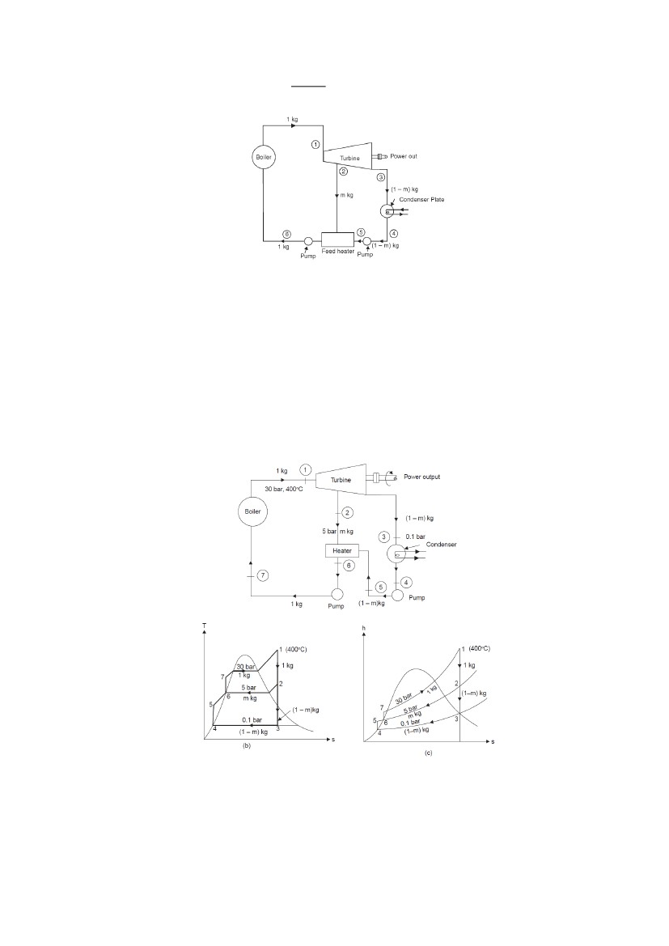
ME 2202 Engineering Thermodynamics Mechanical Engineering
00
0 6
= 49557.5 kg/h
2012 - 2013
Net work developed per kg of steam
= (h1 – h2) + (1 – m) (h2 – h3)
= (3100 – 2500) + (1 – 0.226) (2500 – 2100)
= 600 + 309.6
= 909.6 kJ/kg
∴ Power developed by the turbine
= 12521.5 kW. (Ans.)
11. In a single-heater regenerative cycle the steam enters the turbine at 30 bar, 400°C and the
exhaust pressure is 0.10 bar. The feed water heater is a direct contact type which operates at 5
bar. Find :
(i) The efficiency and the steam rate of the cycle.
(ii) The increase in mean temperature of heat addition, efficiency and steam rate as compared to
the Rankine cycle (without regeneration).
Pump work may be neglected.
From steam tables :
At 30 bar, 400°C : h1 = 3230.9 kJ/kg,
s1 = 6.921 kJ/kg K = s2 = s3,
At 5 bar :sf = 1.8604,
sg = 6.8192 kJ/kg K,
hf = 640.1 kJ/kg
Since s2 > sg, the state 2 must lie in the superheated region. From the table for superheated steam
t2 = 172°C,
h2 = 2796 kJ/kg.
SK Engineering Academy
35


ME 2202 Engineering Thermodynamics Mechanical Engineering
sf = 0.649,
sfg = 7.501,
hf = 191.8,
hfg = 2392.8
Now, s2 = s3
i.e., 6.921 = sf3 + x3 sfg3
= 0.649 + x3 × 7.501
x3 = 0.836
h3 = hf3 + x3 hfg3
= 191.8 + 0.836 × 2392.8
= 2192.2 kJ/kg
Since pump work is neglected
hf4 = 191.8 kJ/kg = hf5
hf6 = 640.1 kJ/kg (at 5 bar) = hf7
Energy balance for heater gives
m (h2 – hf6 ) = (1 – m) (hf6– hf5)
m (2796 – 640.1) = (1 – m) (640.1 – 191.8) = 448.3 (1 – m)
2155.9 m = 448.3 – 448.3 m
∴ m = 0.172 kg
∴ Turbine work, WT = (h1 – h2) + (1 – m) (h2 – h3)
= (3230.9 – 2796) + (1 – 0.172) (2796 – 2192.2)
= 434.9 + 499.9 = 934.8 kJ/kg
Heat supplied, Q1 = h1 – hf6
= 3230.9 – 640.1
= 2590.8 kJ/kg.
(i) Efficiency of cycle, ηcycle :
8
08
= 0.3608 or 36.08%. (Ans.)
Steam rate =
= 3.85 kg/kWh. (Ans.)
(ii)
0
8
606
= 484.5 K
= 211.5°C.
Increase in Tm1 due to regeneration
= 238.9 – 211.5
= 27.4°C. (Ans.)
WT (without regeneration)
= h1 – h3
= 3230.9 – 2192.2
= 1038.7 kJ/kg
Steam rate without regeneration
600
0 8
= 3.46 kg/kWh
∴ Increase in steam rate due to regeneration
= 3.85 – 3.46
= 0.39 kg/kWh. (Ans.)
ηcycle (without regeneration) =
= 0.3418 or 34.18%. (Ans.)
Increase in cycle efficiency due to regeneration
SK Engineering Academy
36
At 0.1 bar :
2012 - 2013

ME 2202 Engineering Thermodynamics Mechanical Engineering
= 36.08 – 34.18
= 1.9%. (Ans.)
2012 - 2013
UNIT IV
Ideal and Real Gases and Thermodynamic Relations
2 Marks
1. Define Ideal gas.
It is defined as a gas having no forces of intermolecular attraction. These gases will follow the gas
laws at all ranges of pressures and temperatures.
2. Define Real gas.
It is defined, as a gas having the forces of attraction between molecules tends to be very small at
reduced pressures and elevated temperatures.
3. What is equation of state?
The relation between the independent properties such as pressure, specific volume and temperature for
a pure substance is known as the equation of state.
4. State Boyle’s law.
It states that volume of a given mass of a perfect gas varies inversely as the absolute pressure when
temperature is constant.
5. State Charle’s law.
It states that if any gas is heated at constant pressure, its volume changes directly as its absolute
temperature.
6. Explain the construction and give the use of generalized compressibility chart.
The general compressibility chart is plotted with Z versus Pr for various values of Tr. This is
constructed by plotting the known data of one of mole gases and can be used for any gas. This chart
gives best results for the regions well removed from the critical state for all gases.
7. What do you mean by reduced properties?
The ratios of pressure, temperature and specific volume of a real gas to the corresponding critical
values are called the reduced properties.
8. Explain law of corresponding states.
If any two gases have equal values of reduced pressure and reduced temperature, then they have same
values of reduced volume.
9. Explain Dalton’s law of partial pressure.
The pressure of a mixture of gases is equal to the sum of the partial pressures of the constituents. The
partial pressure of each constituent is that pressure which the gas would expect if it occupied alone that
volume occupied by the mixtures at the same temperatures. m = mA+mB+mC+……. = mi
mi = mass of the constituent.
P=PA+PB+PC+……. = Pi, Pi – the partial pressure of a constituent.
10. State Avogardo’s Law.
The number of moles of any gas is proportional to the volume of gas at a given pressure and
temperature.
11. What is compressibility factor?
The gas equation for an ideal gas is given by (PV/RT) = 1, for real gas (PV/RT) is not equal to 1
(PV/RT) = Z for real gas is called the compressibility factor.
12. What is partial pressure?
The partial pressure of each constituent is that pressure which the gas would exert if it occupied alone
that volume occupied by the mixtures at the same temperature.
13. Define Dalton’s law of partial pressure.
The total pressure exerted in a closed vessel containing a number of gases is equal to the sum of the
pressures of each gas and the volume of each gas equal to the volume of the vessel.
14. How does the Vander Waal’s equation differ from the ideal gas equation of state?
The ideal gas equation pV=mRT has two important assumptions,
1. There is little or no attraction between the molecules of the gas.
2. That the volume occupied by the molecules themselves is negligibly small compared to the volume
of the gas. This equation holds good for low pressure and high temperature ranges as the
intermolecular attraction and the volume of the molecules are not of much significance.
SK Engineering Academy
37


ME 2202 Engineering Thermodynamics Mechanical Engineering
2012 - 2013
As the pressure increases, the inter molecular forces of attraction and repulsion increases and the
volume of the molecules are not negligible. The real gas deviates considerably from the ideal gas
equation [p+(a/V2)](V-b) = RT
15. Explain Joule-Kelvin effect. What is inversion temperature?
When a gas (not ideal gas) is throttled, the temperature increases up to a point and then decreases. This
is known as Joule Kelvin effect. The temperature at which the slope of a throttling curve in T-p
diagram is zero is inversion temperature.
16 Marks
1.
Drive Maxwell relations
The first law applied to a closed system undergoing a reversible process states that
dQ = du + pdv
According to second law,
( )
Combining these equations, we get
Tds = du + pdv
ordu = Tds – pdv
The properties h, f and g may also be put in terms of T, s, p and v as follows :
dh = du + pdv + vdp = Tds + vdp
Helmholtz free energy function,
df = du – Tds – sdT
= – pdv – sdT
Gibb’s free energy function,
dg = dh – Tds – sdT = vdp – sdT
Each of these equations is a result of the two laws of thermodynamics.
Since du, dh, df and dg are the exact differentials, we can express them as
( )( )
( )
( )
(
)
( )
( )
(
)
Comparing these equations we may equate the corresponding co-efficients.
For example, from the two equations for du, we have
( )( )
The complete group of such relations may be summarised as follows :
( )( )
( )
( )
( )
Also,
( )
( )
( )
( )
2.
( )
( )
( )
( )
( )
( )
( )
(a) 1 kg of air at a pressure of 8 bar and a temperature of 100°C undergoes a reversible
polytropic process following the law pv1.2 = constant. If the final pressure is 1.8 bar determine :
(i) The final specific volume, temperature and increase in entropy ;
38

SK Engineering Academy

ME 2202 Engineering Thermodynamics Mechanical Engineering
(ii) The work done and the heat transfer.
Assume R = 0.287 kJ/kg K and γ = 1.4.
(b) Repeat (a) assuming the process to be irreversible and adiabatic between end states.
Solution. (a)Mass of air,m = 1 kg
Pressure,p1 = 8 bar
Temperature,T1 = 100 + 273 = 373 K
The law followed : pv1.2 = constant
Final pressure,p2 = 1.8 bar
Characteristic gas constant, R = 0.287 kJ/kg K
Ratio of specific heats, γ = 1.4
(i) v2, T2 and Δs :
Assuming air to be a perfect gas,
p1v1 = RT1
000)
80
= 0.1338 m3/kg
Also, p1v11.2 = p2v21.2
(
(
)
(0 8
2012 - 2013
⁄
⁄
⁄
)
08( )
= 0.4637 m3/kg
i.e., Final specific volume, v2 = 0.4637 m3/kg. (Ans.)
Again, p2v2 = RT2
80 0 6
(0 8000)
= 290.8 K
i.e., Final temperature,t2 = 290.8 – 273 = 17.8°C. (Ans.)
Increase in entropy Δs is given by,
( )
But,
= 1.4 (given) ...(i)
( )
and cp – cv = R (= 0.287 kJ/kg K for air) ...(ii)
Solving for cv between (i) and (ii),
cv = 0.717 kJ/kg K
08
0() 0 8
0 6
()
08
= – 0.1785 + 0.3567 = 0.1782 kJ/kg K
i.e., Increase in entropy, Δs = 0.1782 kJ/kg K. (Ans.)
(ii) Work done and heat transfer :
The work done in a polytropic process is given by,
()
0 8 (
0 8)
= 117.96 kJ/kg
i.e., Work done = 117.96 kJ/kg. (Ans.)
Heat transfer, Q = Δu + W
where Δu = cv(T2 – T1)
= 0.717 (290.8 – 373)
SK Engineering Academy
39


ME 2202 Engineering Thermodynamics Mechanical Engineering
2012 - 2013
3.
= – 58.94 kJ/kg
∴ Q = – 58.94 + 117.96
= 59.02 kJ/kg
Hence heat transfer = 59.02 kJ/kg. (Ans.)
(b) (i) Though the process is assumed now to be irreversible and adiabatic, the end states are
given to be the same as in (a). Therefore, all the properties at the end of the process are the same
as in (a). (Ans.)
(ii) As the process is adiabatic, Q (heat transfer) = 0. (Ans.)
Δu = Δu in (a)
Applying first law for this process
Q = Δu + W
0 = Δu + W
or W = – Δu
= – (– 58.94) = 58.94
∴ Work done = 58.94 kJ/kg. (Ans.)
A container of 3 m3 capacity contains 10 kg of CO2 at 27°C. Estimate the pressure exerted by
CO2 by using :
(i) Perfect gas equation
(ii) Van der Waals’ equation
(iii) Beattie Bridgeman equation.
Solution. Capacity of the container, V = 3 m3
Mass of CO2, m = 10 kg
Temperature of CO2, T = 27 + 273 = 300 K
Pressure exerted by CO2, p :
(i) Using perfect gas equation :
Characteristic gas constant, R =
= 188.95 Nm/kg K (for CO2)
Using perfect gas equation
pV = mRT
0
88
00
= 188950 N/m2 or 1.889 bar. (Ans.)
(ii) Using Van der Waals’ equation :
)() (̅
̅
̅̅4
For CO2 : a = 362850 Nm /(kg-mol)2
b = 0.0423 m3/(kg-mol)
̅ = Molar specific volume =
= 13.2 m3/kg-mol
Now substituting the values in the above equation, we get
8006 8 0
00
= 189562 – 2082.5
= 187479.5 N/m2 or 1.875 bar. (Ans.)
(iii) Using Beattie Bridgeman equation :
()
(̅)
̅̅
where p = pressure, A =(), B =(
̅
A0 = 507.2836, a = 0.07132
B0 = 0.10476, b = 0.07235
C = 66 × 104
A= 0 8 6 ()
SK Engineering Academy
40
̅
) and e = ̅


ME 2202 Engineering Thermodynamics Mechanical Engineering
= 504.5
B=0 0 6 (
= 0.1042
e=
(
)
2012 - 2013
)
= 0.001852
Now substituting the various values in the above equation, we get
800 (0 00 8 )
(
0 0
)
0
4.
= 190093 – 2.89
= 1.9 × 105 N/m2
= 1.9 bar. (Ans.)
3
A vessel of 0.35 m capacity contains 0.4 kg of carbon monoxide (molecular weight = 28) and 1
kg of air at 20°C. Calculate :
(i) The partial pressure of each constituent,
(ii) The total pressure in the vessel, and
The gravimetric analysis of air is to be taken as 23.3% oxygen (molecular weight = 32) and
76.7% nitrogen (molecular weight = 28).
Solution. Capacity of the vessel, V = 0.35 m3
Mass of carbon monoxide = 0.4 kg
Mass of air= 1 kg
Temperature,T = 20°C or 293 K
Mass of oxygen present in 1 kg of air == 0.233 kg
Mass of nitrogen present in 1 kg of air == 0.767 kg
But, characteristic gas constant,
R=
where, R0 = Universal gas constant (= 8.314 kJ/kg K), and M = Molecular weight.
Also, the characteristic gas equation is given by
pV = mRT
Hence, for a constituent,
Substituting the values, we get the partial pressures as follows :
(i) Partial pressures :
For O2,
08
00
= 0.5068 bar. (Ans.)
For N2,
0 68
8 00
= 1.9065 bar (Ans.)
For CO,
0 0 8
8 00
= 0.9943 bar. (Ans.)
(ii) Total pressure in the vessel, p :
p = Σ pi = pO2 + pN2 + pCO
= 0.5068 + 1.9065 + 0.9943
= 3.4076 bar. (Ans.)
SK Engineering Academy
41


ME 2202 Engineering Thermodynamics Mechanical Engineering
5.
2012 - 2013
A vessel contains at 1 bar and 20°C a mixture of 1 mole of CO2 and 4 moles of air. Calculate for
the mixture :
(i) The masses of CO2, O2 and N2, and the total mass ;
(ii) The percentage carbon content by mass ;
(iii) The apparent molecular weight and the gas constant for the mixture ;
(iv) The specific volume of the mixture.
The volumetric analysis of air can be taken as 21% oxygen and 79% nitrogen.
Solution. The pressure in the vessel, p = 1 bar
Temperature in the vessel, T = 20 + 273 = 293 K
No. of moles ofCO2 = 1 mole
No. of moles of air= 4 mole
From equation,
( ) we have
nO2 = 0.21 × 4
= 0.84
nN2 = 0.79 × 4
= 3.16
(i) From equation,mi = niMi, we have
mCO2 = 1 × 44
= 44 kg. (Ans.)
mO2 = 0.84 × 32
= 26.88 kg. (Ans.)
and mN2 = 3.16 × 28
= 88.48 kg. (Ans.)
The total mass, m = mCO2 + mO2 + mN2
= 44 + 26.88 + 88.48
= 159.36 kg. (Ans.)
(ii) Since the molecular weight of carbon is 12, therefore, there are 12 kg of carbon
present for every mole of CO2,
i.e., Percentage carbon in mixture == 7.53% by mass. (Ans.)
(iii) From equation n = Σ ni, we have
n = nCO2 + nO2 + nN2
= 1 + 0.84 + 3.16
= 5.0
Now using the equation M = Σ, we have
086
8
= 8.8 + 5.376 + 17.696
= 31.872
i.e., Apparent molecular weight = 31.872. (Ans.)
From equation, R = , we have
R=
= 0.2608 kJ/kg K
i.e., Gas constant for the mixture = 0.2608 kJ/kg K. (Ans.)
(iv) To find specific volume of the mixture, v using the relation :
pv = RT
0
0
= 0.7641 m3/kg
i.e., Specific volume of the mixture = 0.7641 m3/kg. (Ans.)
0 608
SK Engineering Academy
42


ME 2202 Engineering Thermodynamics Mechanical Engineering
6.
2012 - 2013
A mixture of ideal gases consists of 4 kg of nitrogen and 6 kg of carbon dioxide at a pressure of
4 bar and a temperature of 20°C. Find :
(i) The mole fraction of each constituent,
(ii) The equivalent molecular weight of the mixture,
(iii) The equivalent gas constant of the mixture,
(iv) The partial pressures and partial volumes,
(v) The volume and density of the mixture, and
(vi) The cp and cv of the mixture.
If the mixture is heated at constant volume to 50°C, find the changes in internal energy, enthalpy
and entropy of the mixture. Find the changes in internal energy, enthalpy and entropy of the
mixture if the heating is done at constant pressure.
Take γ : for CO2 = 1.286 and for N2 = 1.4.
Solution. (i) The mole fraction of each constituent :
Since mole fraction,
8
8
6
6
08
08 0
= 0.511. (Ans.)
6
8
6
0 6
08 0 6
= 0.488. (Ans.)
(ii) The equivalent molecular weight of the mixture, M :
M = 0.511 × 28 + 0.488 × 44 = 35.78 kg/kg mole. (Ans.)
(iii) The equivalent gas constant of the mixture, Rmix :
Total mass, m = mN2 + mCO2 = 4 + 6 = 10 kg
8
(
8
(
0
= 0.232 kJ/kg K. (Ans.)
(iv) The partial pressures and partial volumes :
PN2 = xN2 × p
= 0.511 × 4
= 2.044 bar. (Ans.)
PCO2 = xCO2 × p
= 0.488 × 4
= 1.952 bar. (Ans.)
8
3
8
)
6
)
0
= 0.87 m . (Ans.)
8
8
0
6
0
0
= 0.83 m3.
(v) The volume and density of the mixture :
SK Engineering Academy43


ME 2202 Engineering Thermodynamics Mechanical Engineering
Total volume of the mixture,
2012 - 2013
0
0
3
0
0
= 1.699 m . (Ans.)
Density of the mixture,
ρmix = ρN2 + ρCO2
0
63
= 5.88 kg/m . (Ans.)
(vi) cp and cv of the mixture :
cpN – cvN = RN2
2
2
and cpN
2
8
8()
= 0.742 kJ/kg K.
= 1.4 × 0.742 = 1.039 kJ/kg K
(
)
[Since γ for CO2 = 1.286]
and cpCO
For the mixture :
2
= 0.661 kJ/kg K
= 1.286 × 0.661
= 0.85 kJ/kg K
06 08
(6)
= 0.925 kJ/kg K.
6 0 66
(6)
= 0.693 kJ/kg K. (Ans.)
When the mixture is heated at constant volume :
Change in internal energy,
U2 – U1 = mcv(T2 – T1)
= 10 × 0.693(50 – 20)
= 207.9 kJ. (Ans.)
Change in entropy,
H2 – H1 = mcp(T2 – T1)
= 10 × 0.925(50 – 20)
= 277.5 kJ. (Ans.)
Change in entropy,
0
SK Engineering Academy
44


ME 2202 Engineering Thermodynamics Mechanical Engineering
0
06
(
0
)
0
2012 - 2013
= 0.675 kJ/kg K. (Ans.)
When the mixture is heated at constant pressure :
If the mixture is heated at constant pressure ΔU and ΔH will remain the same.
The change in entropy will be
0
7.
3
0
(
)
= 0.902 kJ/kg K. (Ans.)
A vessel of 1.8 m capacity contains oxygen at 8 bar and 50°C. The vessel is connected to
another vessel of 3.6 m3 capacity containing carbon monoxide at 1 bar and 20°C. A connecting
valve is opened and the gases mix adiabatically. Calculate :
(i) The final temperature and pressure of the mixture ;
(ii) The change of entropy of the system.
Take: For oxygen Cv = 21.07 kJ/mole K.
For carbon monoxide Cv = 20.86 kJ/mole K.
Solution. Using the relation,
8
0
8
(80 )
= 0.536 (where TO2 = 50 + 273 = 323 K)
06
(80 )
= 0.1478 (where TCO = 20 + 273 = 293 K).
(i) Final temperature (T) and pressure (p) of the mixture :
Before mixing :
U1 = Σ niCviTi
= 0.536 × 21.07 × 323 + 0.1478 × 20.86 × 293
i.e., U1 = 4551.15 kJ
After mixing :
U2 = T Σ niCvi
= T (0.536 × 21.07 + 0.1478 × 20.86)
i.e., U2 = 14.37 T
For adiabatic mixing,
U1 = U2
∴ 4551.15 = 14.37 T
T = 316.7 K
∴ Temperature of the mixture = 316.7 – 273 = 43.7°C. (Ans.)
(0
6
0
8)
( 8
8
6)
0
0
6
= 3.33 bar
i.e., Pressure after mixing = 3.33 bar. (Ans.)
(ii) Change of entropy of the system :
Change of entropy of the system = change of entropy of the O2 + change of entropy of CO
...... Gibbs-Dalton law
Referring to Figure, the change of entropy of O2 can be calculated by replacing the process
undergone by the oxygen by the two processes 1 to A and A to 2.
For an isothermal process 1-A :
SK Engineering Academy
45


ME 2202 Engineering Thermodynamics Mechanical Engineering
2012 - 2013
0
6
8
8
= 4.896 kJ/K
For constant volume process A-2 :
∫
6
= 0.222 kJ/K
∴ S2 – S1 = (SA – S1) – (SA – S2)
= 4.896 – 0.222
= 4.674 kJ/K
Referring to Figure, the change of entropy of CO can be found in a similar way to the above,
i.e., S2 – S1 = (SB – S1) + (S2 – SB)
6
0
6
0
0
8
8
6
0
8
0 86
8.
= 0.498 + 0.239
= 0.737 kJ/K
Hence the change of entropy of the whole system is given by
(S2 – S1)system = (S2 − S1)O2 + (S2 − S1)CO
i.e., Change of entropy of system = 4.674 + 0.737
= 5.411 kJ/K. (Ans.)
The pressure and temperature of mixture of 4 kg of O2 and 6 kg of N2 are 4 bar and 27°C
respectively. For the mixture determine the following :
(i) The mole fraction of each component ; (ii) The average molecular weight ; (iii) The specific
gas constant ; (iv) The volume and density ; (v) The partial pressures and partial volumes.
Solution. Mass of oxygen, mO2 = 4 kg
Mass of nitrogen, mN2= 6 kg
Pressure,p = 4 bar
Temperature,T = 27 + 273 = 300 K.
(i) The mole fraction of each component :
= 0.125
6
8
= 0.214
0
= 0.3687
SK Engineering Academy
0
0
46


ME 2202 Engineering Thermodynamics Mechanical Engineering
0
00
= 0.6313
(ii) The average molecular weight, M :
2012 - 2013
0
0
= 29.475
i.e., Average molecular weight = 29.475. (Ans.)
(iii) The specific gas constant, R :
8
0
0
8
= 0.282 kJ/kg K.
(iv) The volume and density :
pV = mRT for mixture
(
6)
0 8
0
0
00
= 2.115 m3. (Ans.)
Density, ρ = ρO2 ρN2
= 1.891 kg/m3
6
= 2.837 kg/m3
∴ ρ = 1.891 + 2.837
= 4.728 kg/m3. (Ans.)
(v) The partial pressures and partial volumes :
pO2 V = nO2R0T
0
8
0
0
00
9.
= 1.474 bar. (Ans.)
and
pN2 = 4 – 1.474
= 2.526 bar. (Ans.)
V O2 = xO2 V
= 0.3687 × 2.115
= 0.779 m3. (Ans.)
V N2 = xN2 V
= 0.6313 × 2.115
= 1.335 m3. (Ans.)
Drive entropy equations (Tds Equations)
Since entropy may be expressed as a function of any other two properties,
e.g. temperature T and specific volume v,
s = f(T, v)
47

SK Engineering Academy

ME 2202 Engineering Thermodynamics Mechanical Engineering
(
(
)
)
(
)
(
)
2012 - 2013
But for a reversible constant volume change
dq = cv (dT)v = T(ds)v
(
(
)
(
)
(
)
)
Hence, substituting in above equation, we get
This is known as the first form of entropy equation or the first Tds equation.
Similarly, writing
s = f(T, p)
(
(
(
)
(
)
)
)
(
)
(
)
This is known as the second form of entropy equation or the second Tds equation.
10. Drive equations for internal energy and enthalpy.
(i)Let u = f(T, v)
(
)
(
(
let
)
u = f (s, v)
(
(
(
(
(
(
)
)
)
)
)
(
)
(
)
(
)
) (
)
(
)
(
)
(
)
)
This is sometimes called the energy equation.
From above equation, we get
{ (
)
}
(ii) To evaluate dh we can follow similar steps as under
h = f(T, p)
(
SK Engineering Academy
)
(
)
48


ME 2202 Engineering Thermodynamics Mechanical Engineering
(
(
)
)
2012 - 2013
let h = f(s, p)
(
(
(
(
(
(
)
)
)
)
)
(
)
(
)
(
)
) (
)
(
)
(
)
From above equation, we get
,
(
) -
UNIT V
Psychrometry
2 Marks
1. What is humidification and dehumidification?
The addition of water vapour into air is humidification and the removal of water
vapour from air is dehumidification.
2. Differentiate absolute humidity and relative humidity.
Absolute humidity is the mass of water vapour present in one kg of dry air.
Relative humidity is the ratio of the actual mass of water vapour present in one kg of dry air at the
given temperature to the maximum mass of water vapour it can with hold at the same temperature.
Absolute humidity is expressed in terms of kg/kg of dry air. Relative humidity is expressed in terms of
percentage.
3. What is effective temperature?
The effective temperature is a measure of feeling warmth or cold to the human body in response to the
air temperature, moisture content and air motion. If the air at different DBT and RH condition carries
the same amount of heat as the heat carried by the air at temperature T and 100% RH, then the
temperature T is known as effective temperature.
4. Define Relative humidity.
It is defined as the ratio of partial pressure of water vapour (pw) in a mixture to the saturation pressure
(ps) of pure water at the same temperature of mixture.
5. Define specific humidity.
It is defined as the ratio of the mass of water vapour (ms) in a given volume to the mass of dry air in a
given volume (ma).
6. Define degree of saturation.
It is the ratio of the actual specific humidity and the saturated specific humidity at the same
temperature of the mixture.
7. What is dew point temperature?
The temperature at which the vapour starts condensing is called dew point temperature. It is also equal
to the saturation temperature at the partial pressure of water vapour in the mixture. The dew point
temperature is an indication of specific humidity.
8. What is meant by dry bulb temperature (DBT)?
The temperature recorded by the thermometer with a dry bulb. The dry bulb thermometer cannot affect
by the moisture present in the air. It is the measure of sensible heat of the air.
SK Engineering Academy
49


ME 2202 Engineering Thermodynamics Mechanical Engineering
2012 - 2013
9. What is meant by wet bulb temperature (WBT)?
It is the temperature recorded by a thermometer whose bulb is covered with cotton wick (wet)
saturated with water. The wet bulb temperature may be the measure of enthalpy of air. WBT is the
lowest temperature recorded by moistened bulb.
10. Define dew point depression.
It is the difference between dry bulb temperature and dew point temperature of air vapour mixture.
11. What is meant by adiabatic saturation temperature (or) thermodynamic wet bulb
temperature?
It is the temperature at which the outlet air can be brought into saturation state by passing through the
water in the long insulated duct (adiabatic) by the evaporation of water due to latent heat of
vapourisation.
12. What is psychrometer?
Psychrometer is an instrument which measures both dry bulb temperature and wet bulb temperature.
13. What is psychrometric chart?
It is the graphical plot with specific humidity and partial pressure of water vapour in y axis and dry
bulb temperature along x axis. The specific volume of mixture, wet bulb temperature, relative
humidity and enthalpy are the properties appeared in the psychrometric chart.
14. Define sensible heat and latent heat.
Sensible heat is the heat that changes the temperature of the substance when added to it or when
abstracted from it. Latent heat is the heat that does not affect the temperature but change of state
occurred by adding the heat or by abstracting the heat.
15. What are the important psychrometric processes?
1. Sensible heating and sensible cooling,
2. Cooling and dehumidification,
3. Heating and humidification,
4. Mixing of air streams,
5. Chemical dehumidification,
6. Adiabatic evaporative cooling.
16. What is meant by adiabatic mixing?
The process of mixing two or more stream of air without any heat transfer to the surrounding is known
as adiabatic mixing. It is happened in air conditioning system.
17. What are the assumptions made in Vanderwaal’s equation of state?
1. There is no inter molecular forces between particles.
2. The volume of molecules is negligible in comparison with the gas.
18. Define coefficient of volume expansion.
The coefficient of volume expansion is defined as the change in volume with the change in
temperature per unit volum
19. State Helmholtz function.
Helmholtz function is the property of a system and is given by subtracting the product of absolute
temperature (T) and entropy (S) from the internal energy (U).
Helmholtz function = U – TS
20. What are thermodynamic properties?
Thermodynamic properties are pressure (p), temperature (T), volume (V), internal energy (U),
enthalpy(H), entropy (S), Helmholtz function and Gibbs function
21. Define throttling process.
When a fluid expands through a minute orifice or slightly opened valve, the process is called as
throttling process. During this process, pressure and velocity are reduced.
22. Define Molecular mass.
Molecular mass is defined as the ratio between total mass of the mixture to the total number of moles
available in the mixture.
23. Define isothermal compressibility.
Isothermal compressibility is defined as the change in volume with change in pressure per unit volume
keeping the temperature constant.
24. Define psychrometry.
The science which deals with the study of behavior of moist air (mixture of dry air and water vapour)
is known as psychrometry.
SK Engineering Academy
50


ME 2202 Engineering Thermodynamics Mechanical Engineering
2012 - 2013
16 Marks
1. The sling psychrometer in a laboratory test recorded the following readings :
Dry bulb temperature = 35°C
Wet bulb temperature = 25°C.
Calculate the following :
(i) Specific humidity (ii) Relative humidity (iii) Vapour density in air (iv) Dew point temperature
(v) Enthalpy of mixture per kg of dry air
Take atmospheric pressure = 1.0132 bar. The sling psychrometer in a laboratory test recorded the
following readings :
Dry bulb temperature = 35°C
Wet bulb temperature = 25°C.
Calculate the following :
(i) Specific humidity (ii) Relative humidity (iii) Vapour density in air (iv) Dew point temperature
(v) Enthalpy of mixture per kg of dry air
Take atmospheric pressure = 1.0132 bar.
Solution. For finding the partial pressure of vapour, using the equation :
[( ) ]()
( )
Corresponding to 25ºC (from steam tables),
(pvs)wb = 0.0317 bar
Substituting the values in the above equation, we get
[ 0](00
00
= 0.0317 – 0.0065 = 0.0252 bar.
(i) Specific humidity,
06
0600
000
= 0.01586 kg/kg of dry air. (Ans.)
(ii) Relative humidity,
00
00 6
[pvs = 0.0563 bar corresponding to 35ºC, from steam tables]
= 0.447 or 44.7%. (Ans.)
(iii) Vapour density :
From characteristic gas equation
pvVv = mvRvTv
where
vapour density,
8
8
)
8
8
)
00
0
(
0008
808
3
= 0.0177 kg/m . (Ans.)
(iv) Dew point temperature, tdp :
Corresponding to 0.0252 bar, from steam tables (by interpolation),
(0 000)
()
(0 0 600)
= 21.2°C. (Ans.)
(v) Enthalpy of mixture per kg of dry air, h :
h = cptdb + Whvapour
= 1.005 × 35 + 0.01586 [hg + 1.88 (tdb – tdp)]
= 35.175 + 0.01586 [2565.3 + 1.88 (35 – 21.2)]
SK Engineering Academy51


ME 2202 Engineering Thermodynamics Mechanical Engineering
2012 - 2013
(where hg = 2565.3 kJ/kg corresponding to 35ºC tdb)
= 76.27 kJ/kg of dry air. (Ans.)
2. One kg of air at 35°C DBT and 60% R.H. is mixed with 2 kg of air at 20°C DBT and 13°C dew
point temperature. Calculate the specific humidity of the mixture.
Solution. For the air at 35°C DBT and 60% R.H. :
Corresponding to 35ºC, from steam tables,
pvs = 0.0563 bar
Relative humidity
pv = φ pvs
= 0.6 × 0.0563
= 0.0338 bar
06
0600 8
000 8
= 0.0214 kg/kg of dry air
Corresponding to 0.0338 bar, from steam tables,
(
6 (6)
(
)
)
= 26.1ºC
Enthalpy, h = cptdb + Whvapour
= 1.005 tdb + W [hg + 1.88 (tdb – tdp)]
= 1.005 × 35 + 0.0214 [2565.3 + 1.88 (35 – 26.1)]
= 90.43 kJ/kg of dry air.
For the air at 20°C DBT and 13°C dew point temperature :
pv is the vapour pressure corresponding to the saturation pressure of steam at 13ºC.
∴ pv = 0.0150 bar
06
0600
000
= 0.00935 kg/kg of dry air
Enthalpy, h = cptdb + Whvapour
= 1.005 × 20 + 0.00935 [hg + 1.88 (tdb – tdp)]
= 20.1 + 0.00935 [2538.1 + 1.88 (20 – 13)]
= 43.95 kJ/kg of dry air
Now enthalpy per kg of moist air
0
[]
000
= 58.54 kJ/kg of moist air
Mass of vapour/kg of moist air
000 00
[]
000
= 0.01316 kg/kg of moist air
Specific humidity of mixture
006
006
= 0.01333 kg/kg of dry air. (Ans.)
3
3. 90 m of air per minute at 20°C and 75% R.H. is heated until its temperature becomes 30°C.
Calculate: (i) R.H. of the heated air. (ii) Heat added to air per minute
(i) For air at 20°C and 75% R.H. :
pvs = 0.0234 bar (from steam tables, at 20ºC)
pv = φ × pvs
= 0.75 × 0.0234
= 0.01755 bar
(0 000 )
( 6)
(0 0 800 )
SK Engineering Academy52

ME 2202 Engineering Thermodynamics Mechanical Engineering
= 15.5ºC
06
2012 - 2013
0600
000
= 0.0109 kg/kg of dry air
Enthalpy, h1 = cptdb + Whvapour
= 1.005 × 20 + 0.0109 [hg + 1.88 (tdb – tdp)]
= 1.005 × 20 + 0.0109 [2538.1 + 1.88(20 – 15.5)]
= 47.85 kJ/kg of dry air
(ii) Relative humidity of heated air :
For air at 30°C DBT :
Since the saturation pressure of water vapour at 30ºC is higher than the saturation
pressure of water vapour at 20ºC so it is sensible heating, where pv is same after heating.
Relative humidity
00
00
= 0.412 or 41.2%
(pvs = 0.0425 bar, corresponding to 30ºC)
i.e., Relative humidity of heated air = 41.2%. (Ans.)
(iii) Heat added to air per minute :
Enthalpy, h2 = cptdb + Whvapour
= 1.005 × 30 + 0.0109 × [hg + 1.88 (tdb – tdp)]
= 1.005 × 30 + 0.0109 [2556.3 + 1.88 (30 – 15.5)]
= 58.31 kJ/kg of dry air
3
Mass of dry air in 90 m of air supplied
()
)0000
8(0)
= 106.5 kg/min.
Amount of heat added per minute
= 106.5 (h2 – h1)
= 106.5 (58.31 – 47.85)
= 1114 kJ. (Ans.)
3
4. 40 m of air at 35°C DBT and 50% R.H. is cooled to 25°C DBT maintaining its specific humidity
constant. Determine :
(i) Relative humidity (R.H.) of cooled air ; (ii) Heat removed from air.
Solution. For air at 35°C DBT and 50% R.H. :
pvs = 0.0563 bar (At 35ºC, from steam tables)
Relative humidity
∴ pv = φ × pvs
= 0.5 × 0.0563
= 0.02815 bar
06
0600 8
000 8
= 0.0177 kg/kg of dry air
h1 = cp tdb1 + W1 [hg1 + 1.88 ( tdb1 – tdp1 )]
tdp1 = 23ºC (corresponding to 0.02815 bar)
∴ h1 = 1.005 × 35 + 0.0177 [2565.3 + 1.88 (35 – 23)]
= 80.98 kJ/kg of dry air
For air at 25°C DBT :
(i) R.H. of cooled air :
Since the specific humidity remains constant the vapour pressure in the air remains constant.
SK Engineering Academy53
( 0

ME 2202 Engineering Thermodynamics Mechanical Engineering
2012 - 2013
00 8
00
= 0.888 or 88.8%
i.e., Relative humidity of the cooled air = 88.8%. (Ans.)
(ii) Heat removed from air :
h2 = cp tdb2 + W2 [hg2 + 1.88 ( tdb2 – tdp2 )]
= 1.005 × 25 + 0.0177 [2547.2 + 1.88 (25 – 23)]
= 70.27 kJ/kg of dry air.
= 0.0177 kg/kg of dry air
sincedoes not change
To find mass of dry air (ma), using the relation :
pava = maRaTa
( 0
00 8
8(
)
0
)
0
= 44.57 kg
∴ Heat removed from 40 m3 of air
= ma (h1 – h2)
= 44.57 (80.98 – 70.27)
= 477.3 kJ. (Ans.)
3
5. 120 m of air per minute at 35°C DBT and 50% relative humidity is cooled to 20°C DBT by
passing through a cooling coil.
Determine the following :
(i) Relative humidity of out coming air and its wet bulb temperature.
(ii) Capacity of cooling coil in tonnes of refrigeration.
(iii) Amount of water vapour removed per hour.
Solution. For the air at 35°C DBT and 50% R.H. :
pvs = 0.0563 bar (At 35ºC, from steam tables)
pv = φ × pvs
= 0.5 × 0.0563
= 0.02815 bar.
06
0600 8
000 8
= 0.0177 kg/kg of dry air.
h1 = cp tdb1 + W1 [hg1 + 1.88 ( tdb1 – tdp1 )]
tdp1 ≈ 23ºC (Corresponding to 0.02815 bar).
∴ h1 = 1.005 × 35 + 0.0177 [2565.3 + 1.88 (35 – 23)]
= 80.98 kJ/kg of dry dir.
For the air at 20°C. As the saturation vapour pressure at 20ºC is 0.0234 bar, less than the vapour
pressure 0.02815 bar at 35ºC, so that condensation takes place and air will be saturated at 20°C.
(i) ∴ Relative humidity of exit air is 100 per cent. (Ans.)
Since the air is saturated, wet bulb temperature is equal to dry bulb temperature = 20°C. (Ans.)
∴ pv = pvs = 0.0234 bar.
06
0600
000
= 0.0147 kg/kg of dry air
h2 = cp tdb2 + W2 [hg2 + 1.88 ( tdb2 – tdp2 )]
= 1.005 × 20 + 0.0147 [2538.1 + 1.88 (20 – 20)]
[Since When air is saturated tdb = tdp]
= 57.41 kJ/kg of dry air
SK Engineering Academy54


ME 2202 Engineering Thermodynamics Mechanical Engineering
The weight of water vapour removed per kg of dry air
= 0.0177 – 0.0147
= 0.003 kg/kg of dry air
Heat removed per kg of dry air
= h1 – h2
= 80.98 – 57.41
= 23.57 kJ/kg of dry air
Mass of dry air passing per minute
2012 - 2013
00 8 )00
8()
= 133.7 kg/min
(ii) Capacity of the cooling coil in tonnes of refrigeration
()
000
60
000
= 13.5 TR. (Ans.)
(iii) Amount of water removed per hour
= ma (W1 – W2) × 60
= 133.7 (0.0177 – 0.0147) × 60
= 24.066 kg/h. (Ans.)
6. It is required to design an air-conditioning plant for a small office room
for following winter conditions :
Outdoor conditions ...... 14ºC DBT and 10ºC WBT
Required conditions ...... 20ºC DBT and 60% R.H.
Amount of air circulation ...... 0.30 m3/min./person.
Seating capacity of office ...... 60.
The required condition is achieved first by heating and then by adiabatic humidifying.
Determine the following :
(i) Heating capacity of the coil in kW and the surface temperature required if the by pass factor of
coil is 0.4.
(ii) The capacity of the humidifier. Solve the problem by using psychrometric chart.
• Locate the points ‘1’ and ‘3’ on the psychrometric chart.
• Draw a constant enthalpy line through ‘3’ and constant specific humidity line through ‘1’.
• Locate the point ‘2’ where the above two lines intersect.
( 0
From the psychrometric chart :
h1 = 29.3 kJ/kg,
h2 = h3 = 42.3 kJ/kg
tdb2 = 24.5ºC,
vs1 = 0.817 m3/kg
The mass of air circulated per minute,
0 0 60
08
SK Engineering Academy55


ME 2202 Engineering Thermodynamics Mechanical Engineering
= 22.03 kg/min.
(i) Heating capacity of the heating coil
= ma(h2 – h1)
= 22.03 (42.3 – 29.3)
= 286.4 kJ/min.
= 4.77 kJ/s or 4.77 kW. (Ans.)
The by-pass factor (BF) of heating coil is given by :
2012 - 2013
0
)0 (
i.e., tdb4 (coil surface temperature) = 32.8ºC. (Ans.)
(ii) The capacity of the humidifier
()
60
000
0 (8 6 6 8)
60
000
= 2.379 kg/h. (Ans.)
7. It is required to design an air-conditioning system for an industrial process for the following hot
and wet summer conditions :
Outdoor conditions ...... 32ºC DBT and 65% R.H.
Required air inlet conditions ...... 25ºC DBT and 60% R.H.
Amount of free air circulated ...... 250 m3/min.
Coil dew temperature ...... 13ºC.
The required condition is achieved by first cooling and dehumidifying and then by heating.
Calculate the following :
(i) The cooling capacity of the cooling coil and its by-pass factor.
(ii) Heating capacity of the heating coil in kW and surface temperature of the heating coil if the
by-pass factor is 0.3.
(iii) The mass of water vapour removed per hour. Solve this problem with the use of
psychrometric chart.
• Locate the points ‘1’, ‘5’ and ‘3’ as shown on psychrometric chart.
• Join the line 1-5.
• Draw constant specific humidity line through ‘3’ which cuts the line 1-5 at point ‘2’.
The point ‘2’ is located in this way.
From psychrometric chart :
h1 = 82.5 kJ/kg
h2 = 47.5 kJ/kg
h3 = 55.7 kJ/kg
h5 = 36.6 kJ/kg
W1 = 19.6 gm/kg,
W3 = 11.8 gm/kg
tdb2 = 17.6ºC,
vs1 = 0.892 m3/kg.
The mass of air supplied per minute,
SK Engineering Academy
56


ME 2202 Engineering Thermodynamics Mechanical Engineering
0
08
= 280.26 kg/min.
(i) The capacity of the cooling coil
() 60
000
)80 6 (8
000
= 42.04 TR. (Ans.)
66
66
2012 - 2013
60
8
= 0.237.
(ii) The heating capacity of the heating coil
= ma (h3 – h2)
= 280.26 (55.7 – 47.5)
= 2298.13 kJ/min
kJ/s
= 38.3 kW. (Ans.)
The by-pass factor of the heating coil is given by
0
∴ tdb6 = 28.2ºC.
Hence surface temperature of heating coil = 28.2ºC. (Ans.)
(iii) The mass of water vapour removed per hour
) 6080 6 (
000
80 6 ( 68) 60
000
= 131.16 kg/h. (Ans.)
8. For the atmospheric air at room temperature of 30ºC and relative humidity of 60% determine
partial pressure of air, humidity ratio, dew point temperature, density and enthalpy of air
Solution:
At 30ºC from steam table,
saturation pressure, pv, sat = 0.0425 bar
Partial pressure of vapour = Relative humidity × pv, sat
= 0.6 × 0.0425
= 0.0255 bar
Partial pressure of air = Total pressure of mixture – Partial pressure of vapour
= 1.013 – 0.0255
= 0.9875 bar
Partial pressure of air = 0.9875 bar
06
000
ω = 0.01606 kg/kg of dry air.
Humidity ratio = 0.01606 kg/kg of dry air
Dew point temperature may be seen from the steam table. The saturation temperature
corresponding to the partial pressure of vapour is 0.0255 bar. Dew point temperature can be
approximated as 21.4ºC by interpolation.
Dew point temperature = 21.4ºC
Density of mixture = Density of air (ρa) + Density of vapour (ρv)
SK Engineering Academy
57

06
00
6

ME 2202 Engineering Thermodynamics Mechanical Engineering
= ρa + ρv
= ρa + ω · ρ a
= ρa (1 + ω)
(
0
0 0 606)
00 606
0 830
= 1.1835 kg/m
Density = 1.1835 kg/m3
Enthalpy of mixture, h = Cp · T + ω (hg at 30ºC + 1.860 (30 – 21.4))
= (1.005 × 30) + (0.01606 × (2540.1 + 1.86 × 8.6))
= 71.2 kJ/kg of dry air
Enthalpy of mixture = 71.2 kJ/kg of dry air
2012 - 2013
SK Engineering Academy
58

